# Azure Honeypot Project (In Progress): Attempted Threat Simulation & Microsoft Sentinel Integration

**Goal**: Deploy and simulate a honeypot environment in Azure using three virtual machines (Windows, Linux, Kali), then ingest and analyze attack data via Microsoft Sentinel.

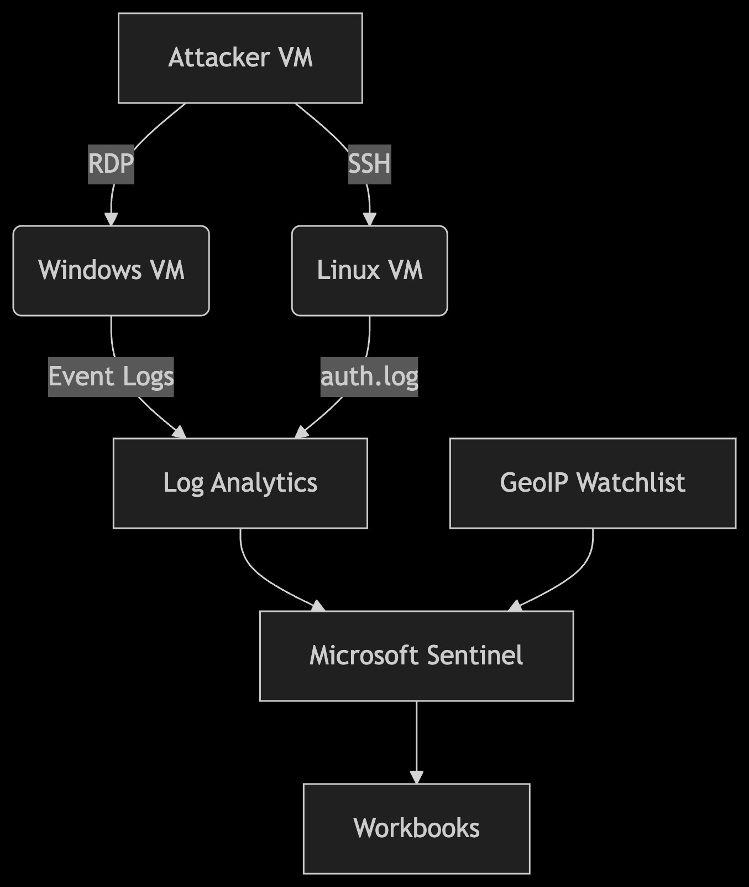

# 1. Initial VM Deployment and Network Configuration

* **Created VMs on Microsoft Azure**:
  + **Windows VM** (IP: 20.121.62.54) o **Linux VM (Ubuntu)** (IP: 172.174.224.24)
  + **Attacker VM**: Initially Kali-Lab-001 (IP: 172.210.240.52), later recreated as attacker-vm (IP: 48.217.80.146)
* Used **Remote Desktop Connection** (RDP) and SSH to connect to each VM from my host machine.
* Tested connectivity using ping but initially received timeouts. Fixed the issue by **disabling Windows Defender Firewall** (Domain, Private, and Public profiles) across all VMs.

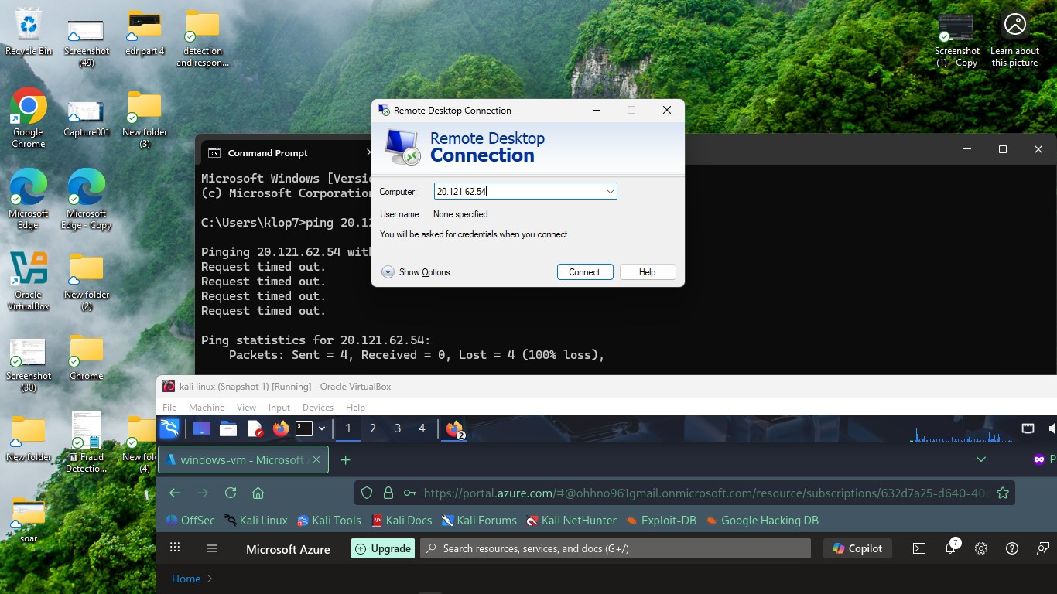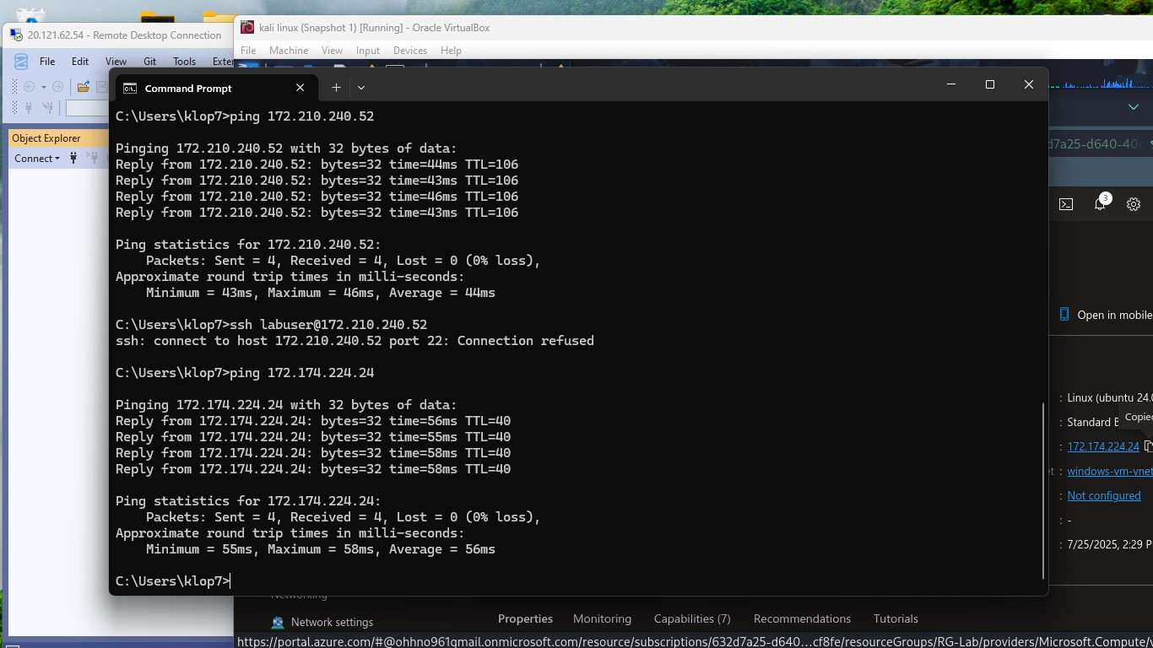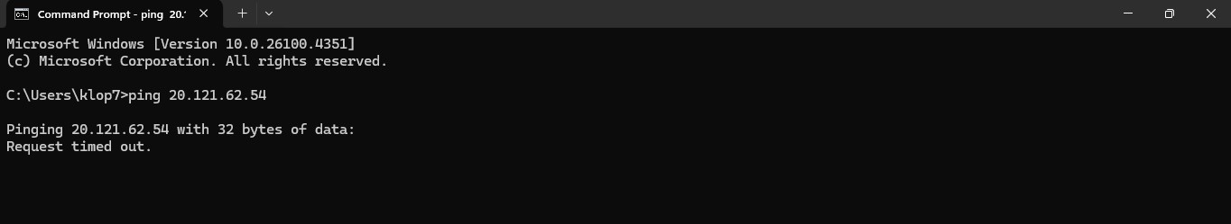

# 2. Simulating Vulnerabilities

* **Disabled all firewall protections** to intentionally expose the VMs to the internet.
* Set **Network Security Group (NSG)** inbound rules to Allow Any for source/destination/port for all VMs.

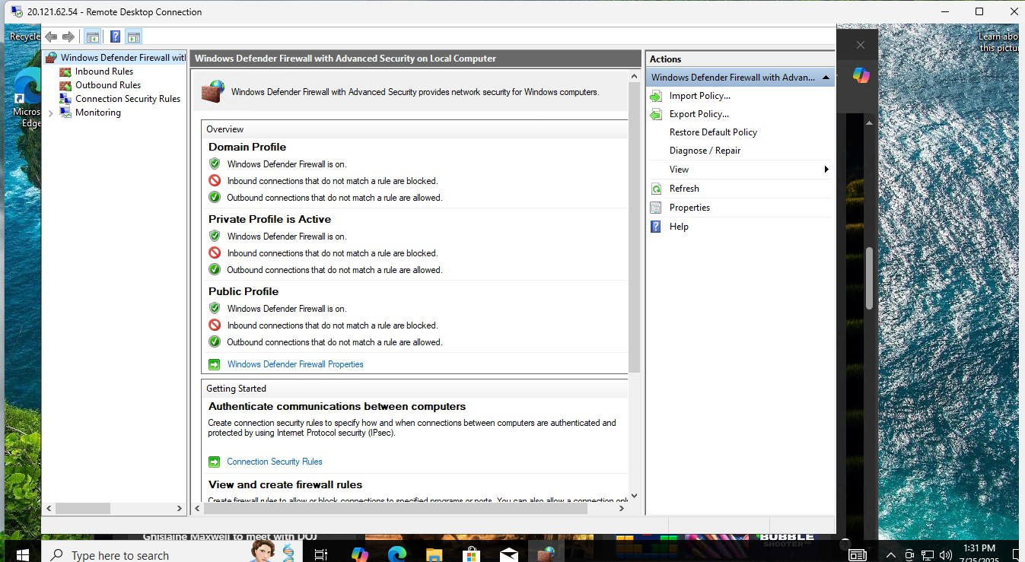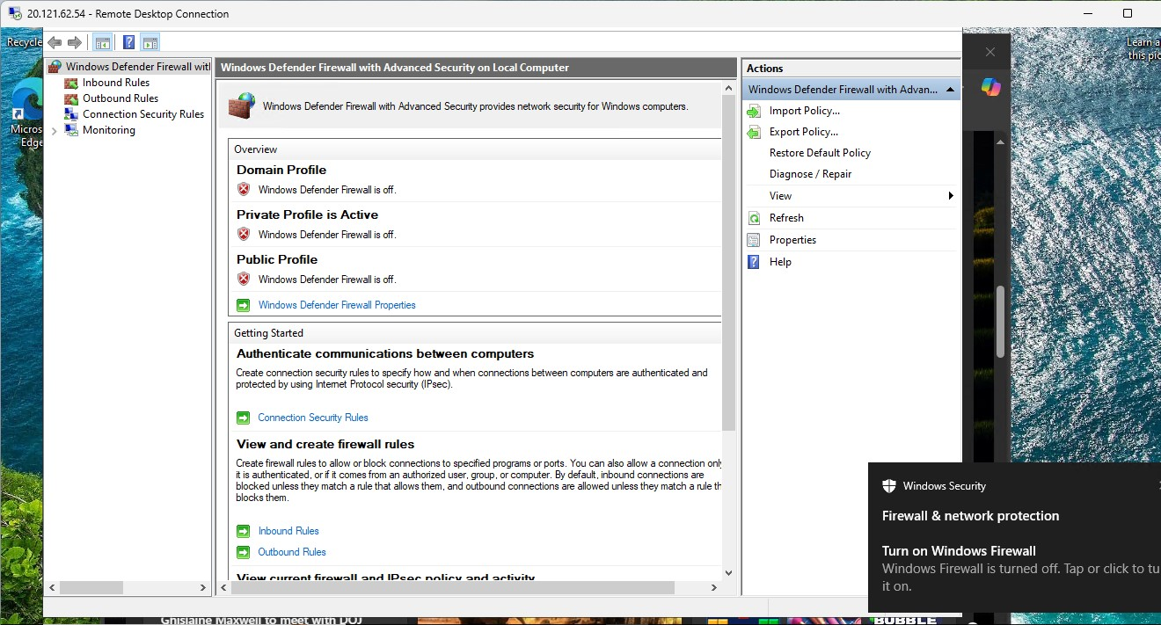

# 3. SQL Server Installation and Auditing on Windows VM

* Installed **SQL Server 2019 (64-bit)** and configured it in **Mixed Mode Authentication**.
* Enabled **Database Engine Services** and set up an sa password.
* Installed **SQL Server Management Studio (SSMS v21)**.
* Followed Microsoft Learn guides to:
  + Grant full registry permissions to NETWORK SERVICE under HKEY_LOCAL_MACHINE\SECURITY.
  + Enable **audit object access** via command:
  + auditpol /set /subcategory:"Audit Object Access" /success:enable /failure:enable
* Verified failed login events by intentionally inputting incorrect SQL credentials; logs appeared in Event Viewer under Windows Logs > Application.

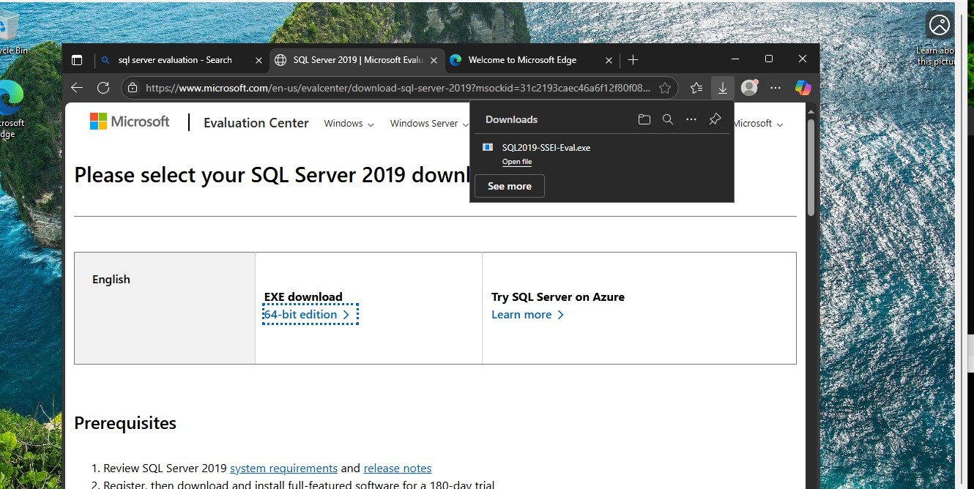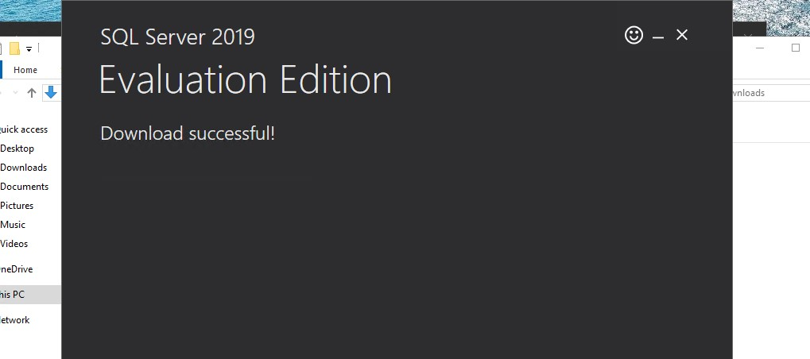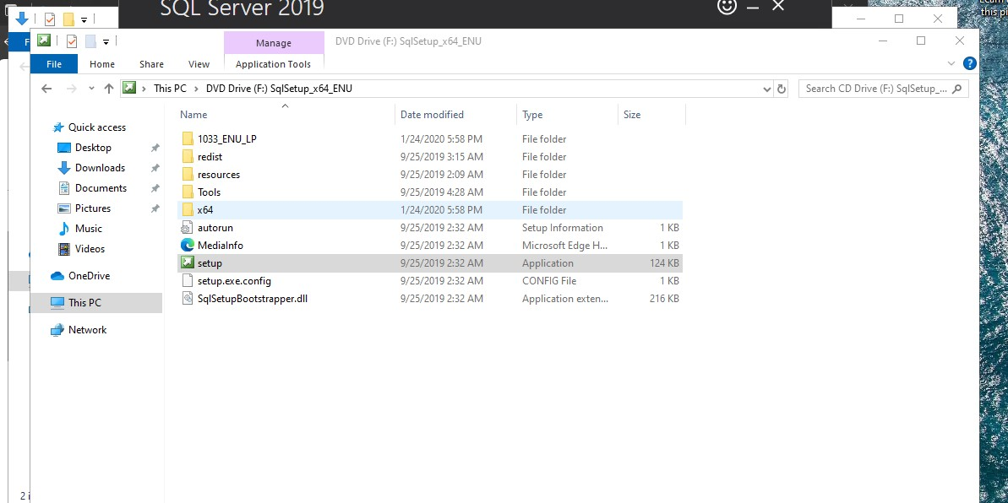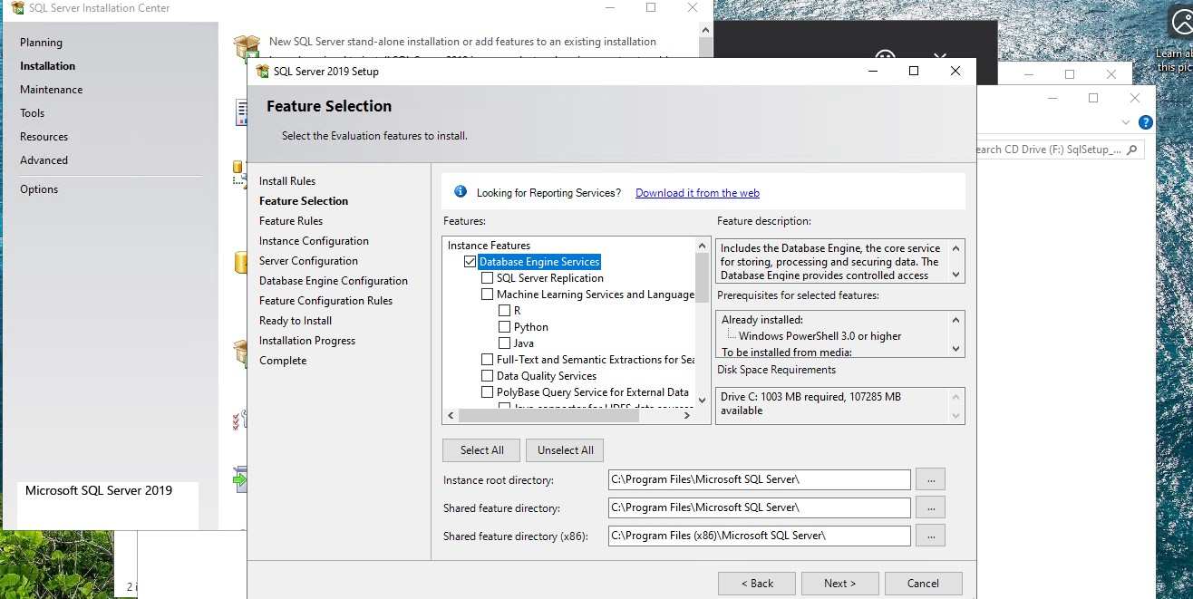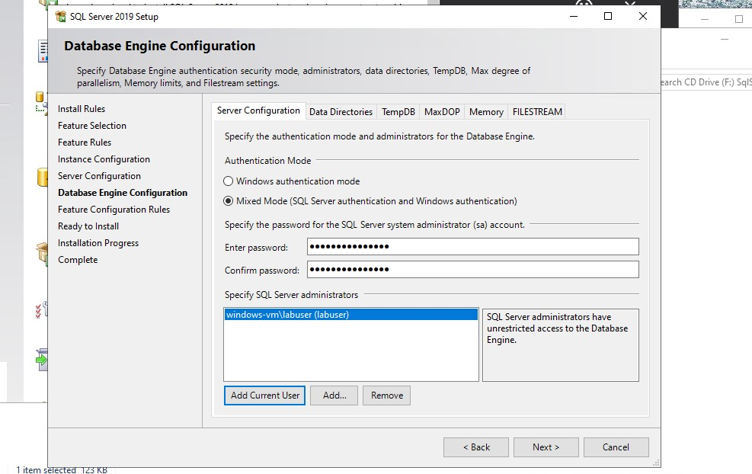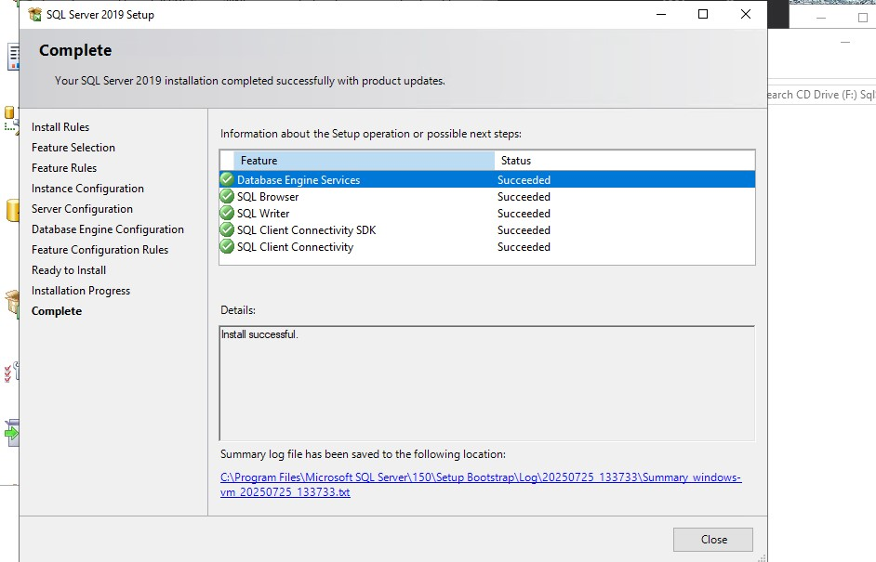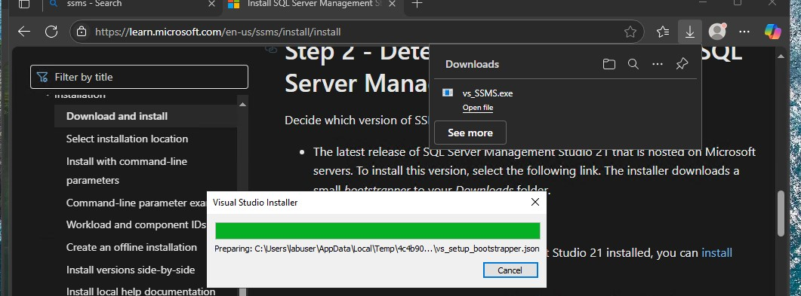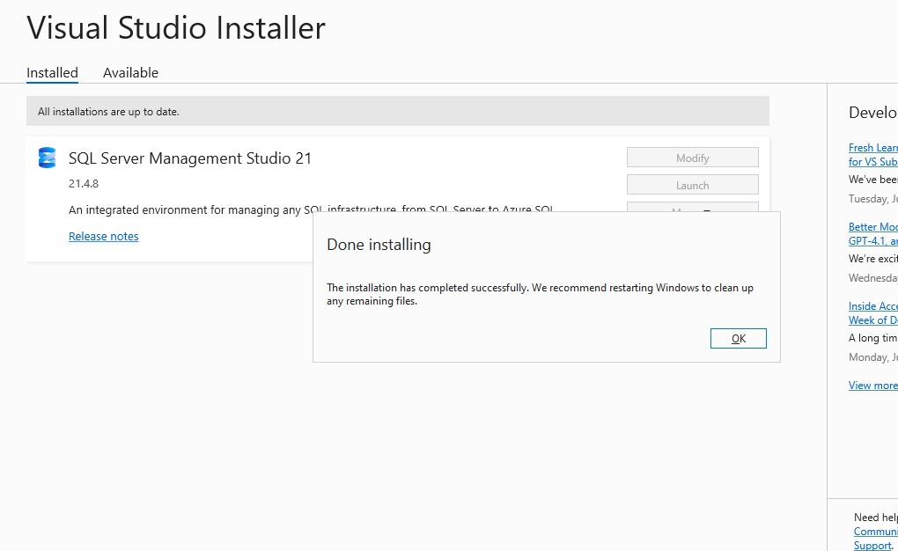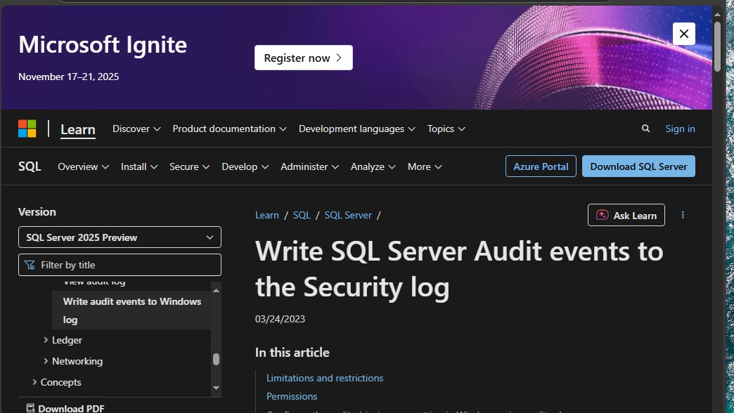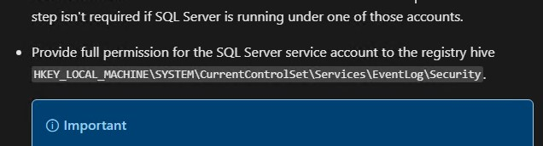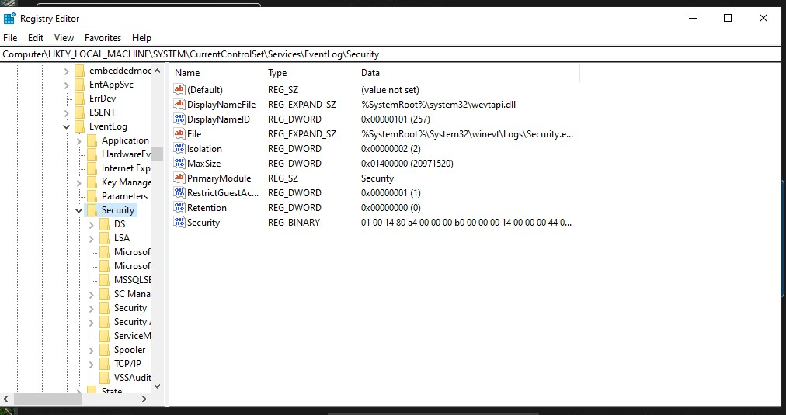

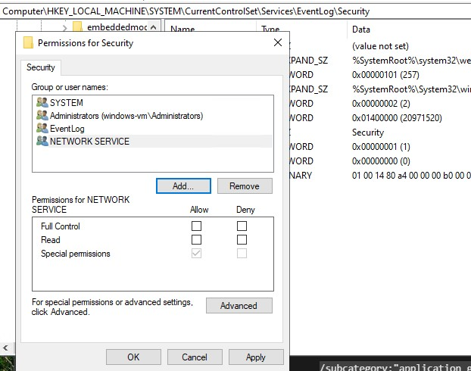

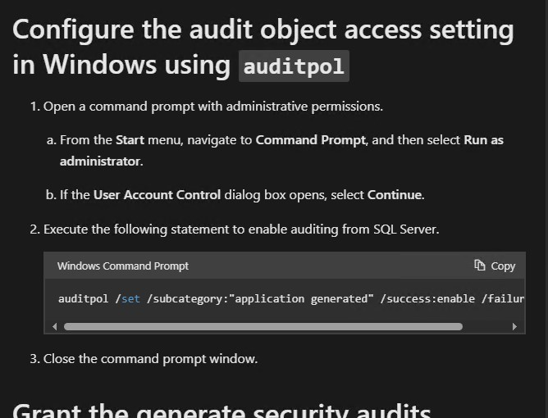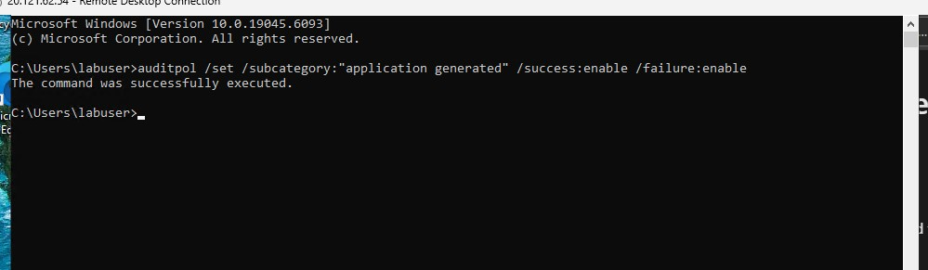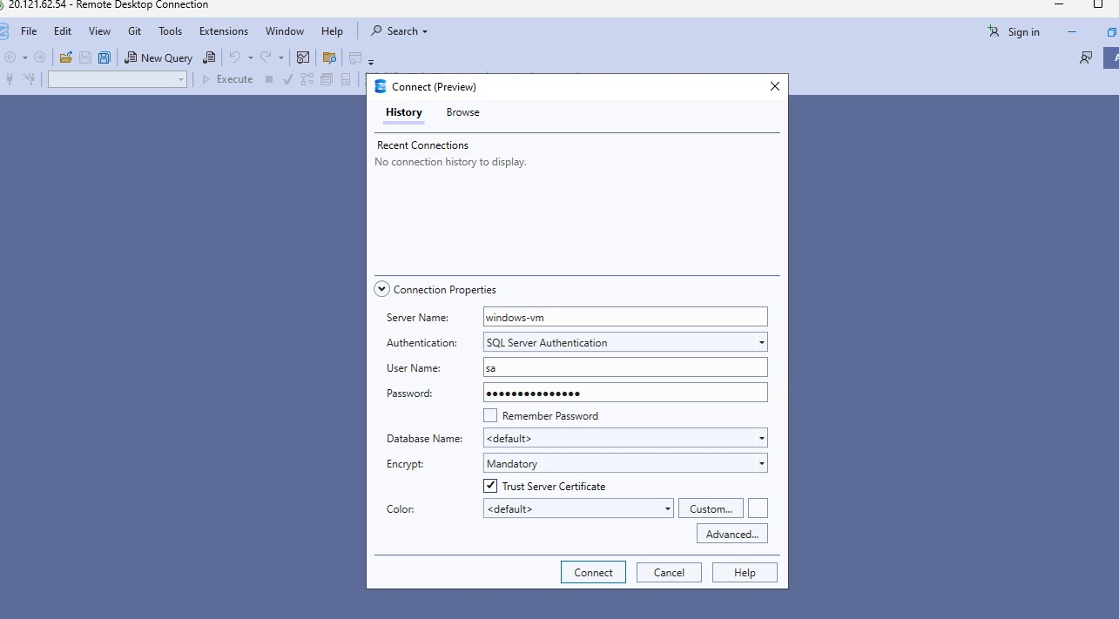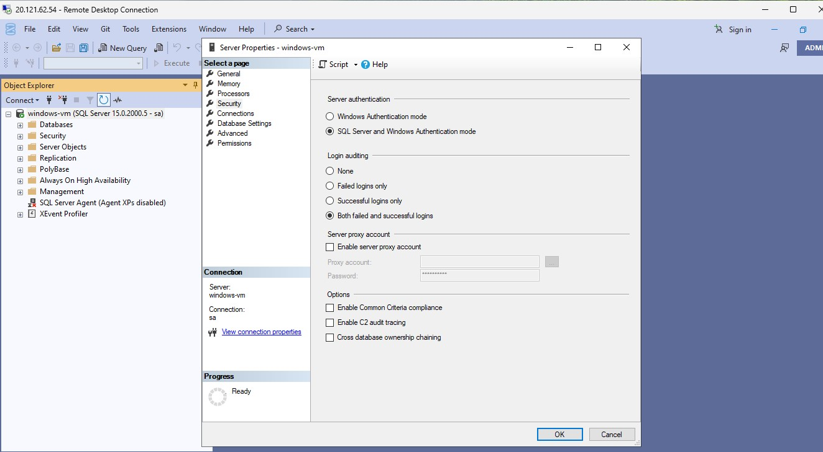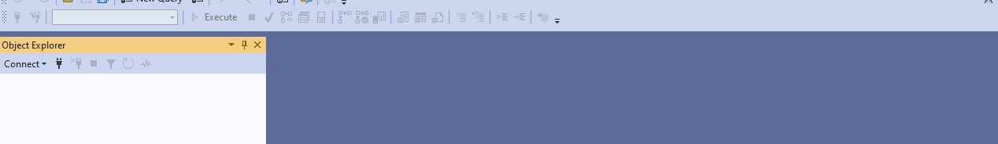

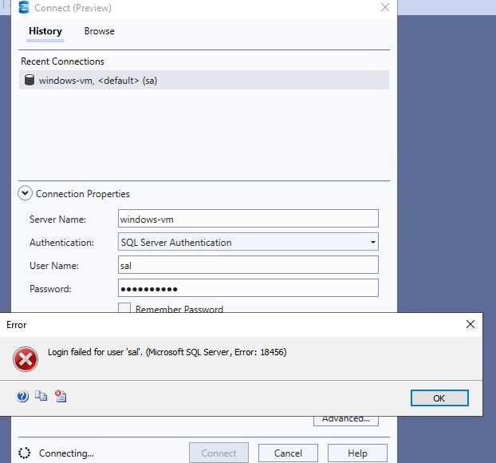

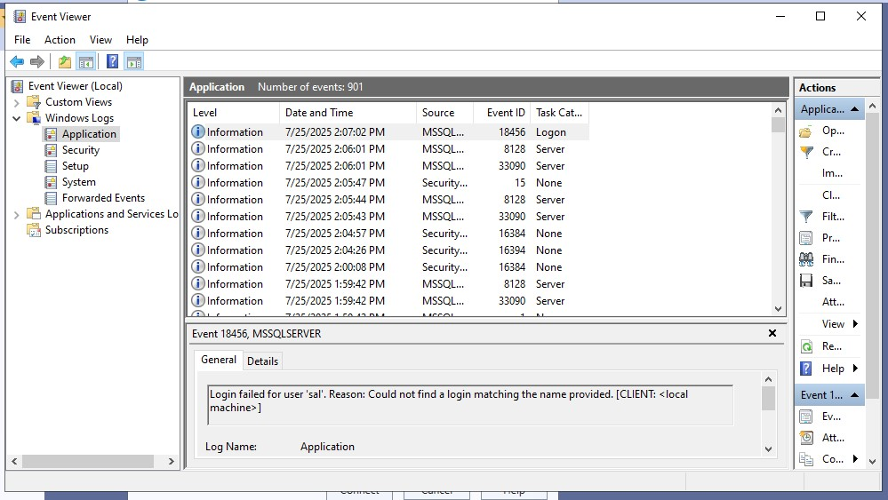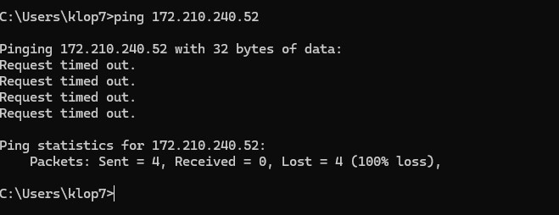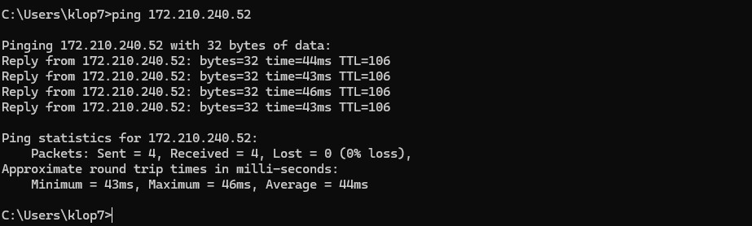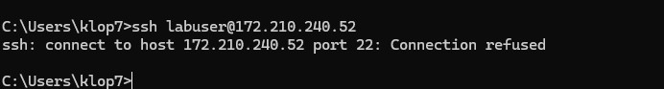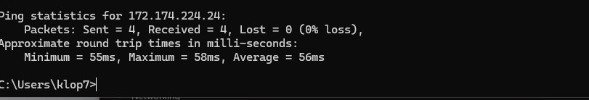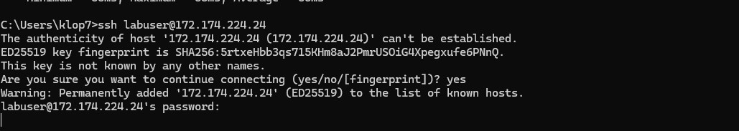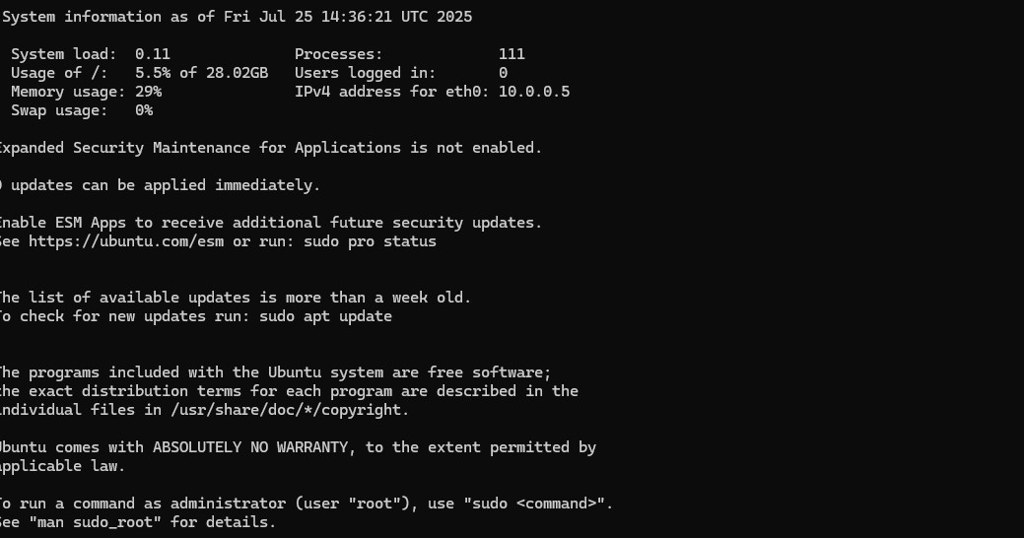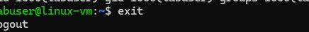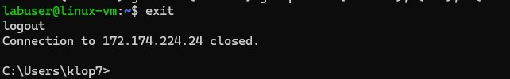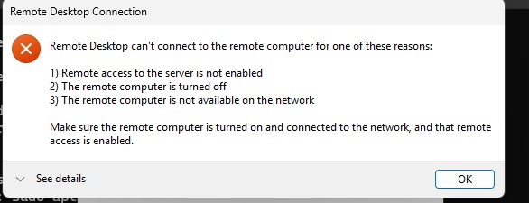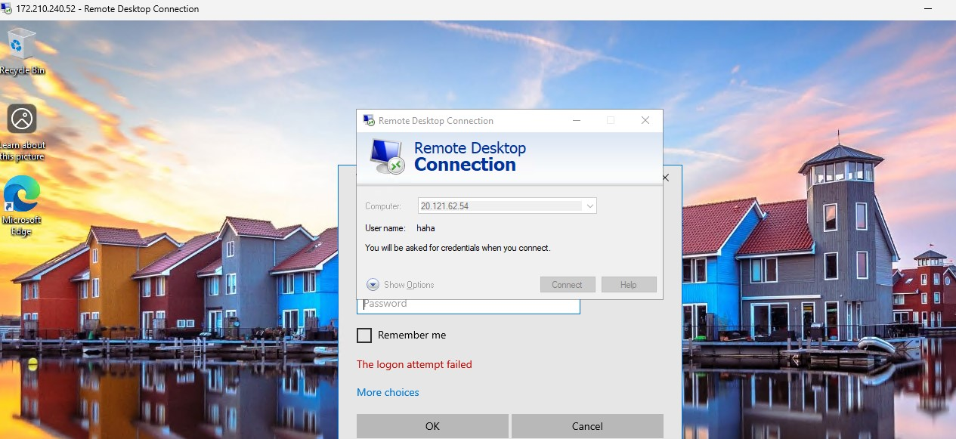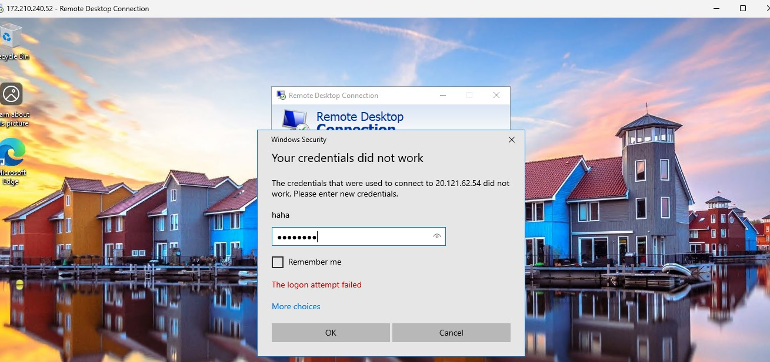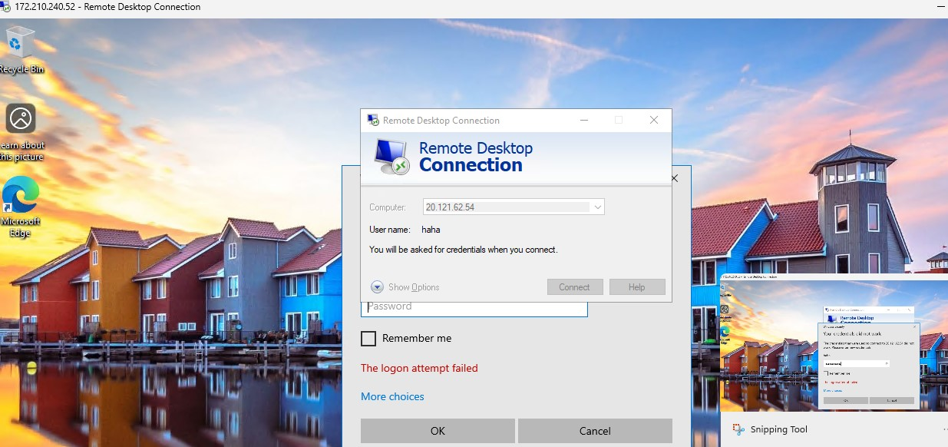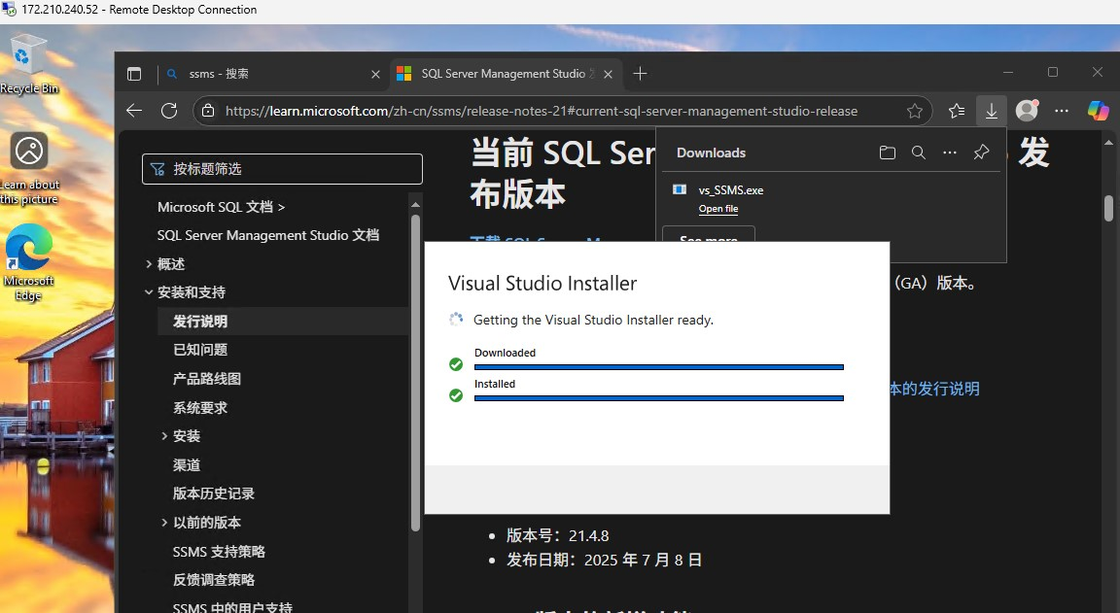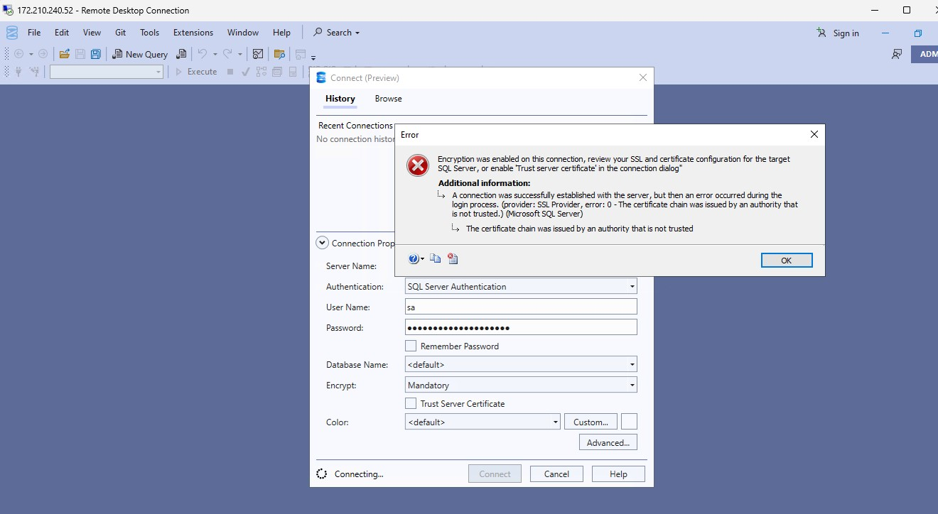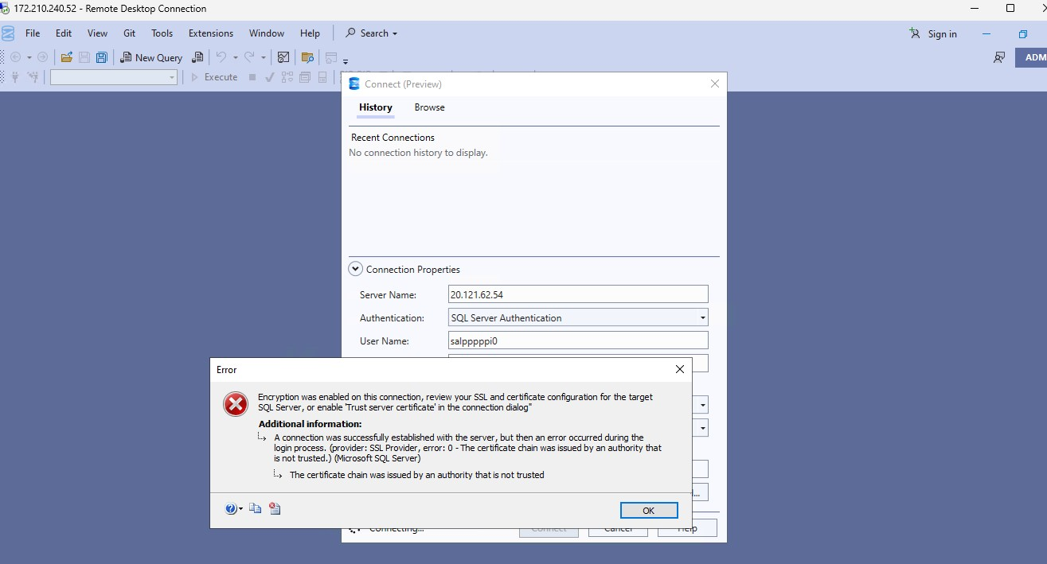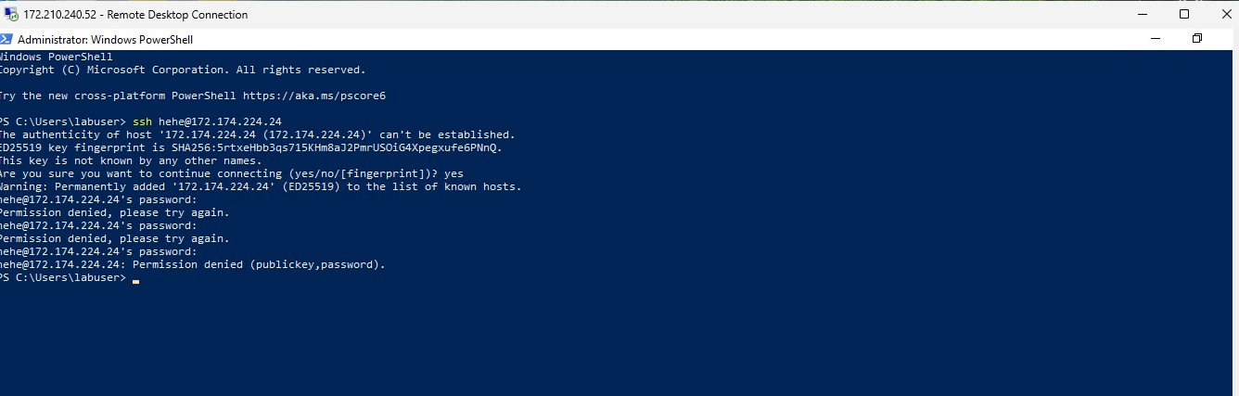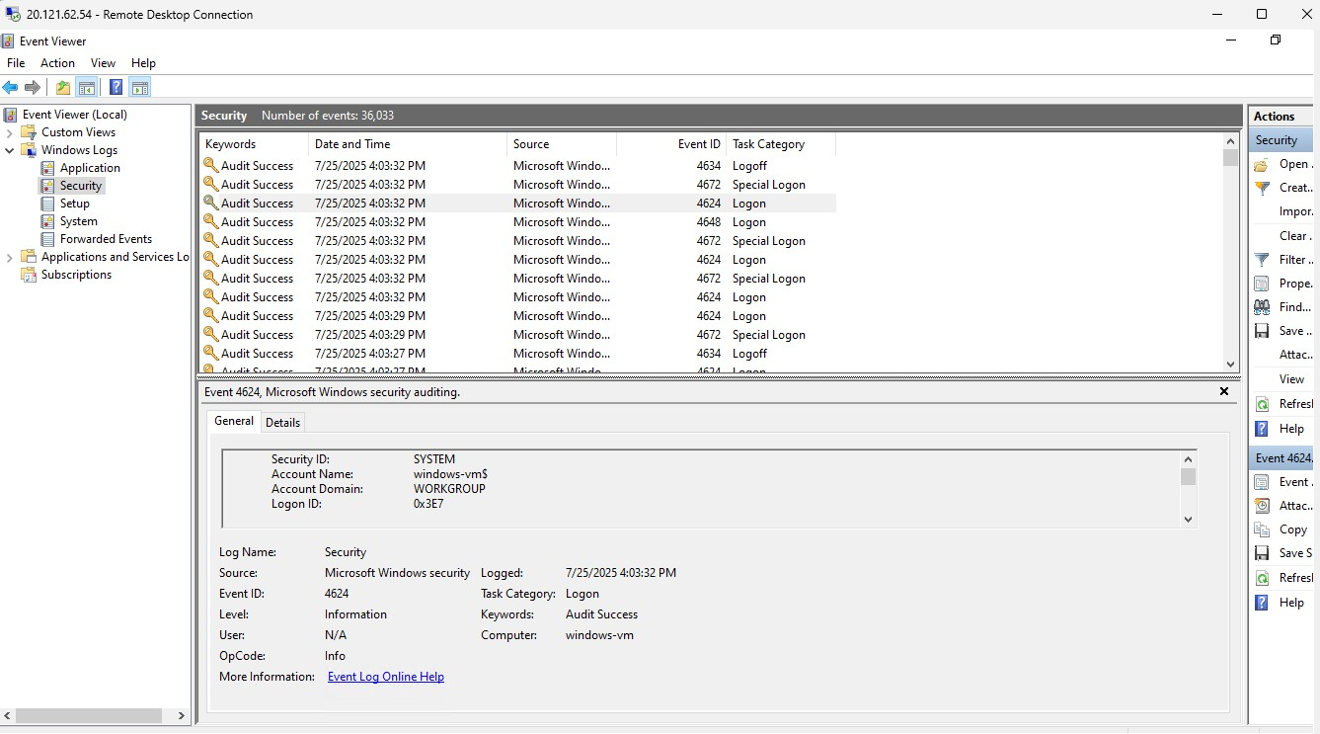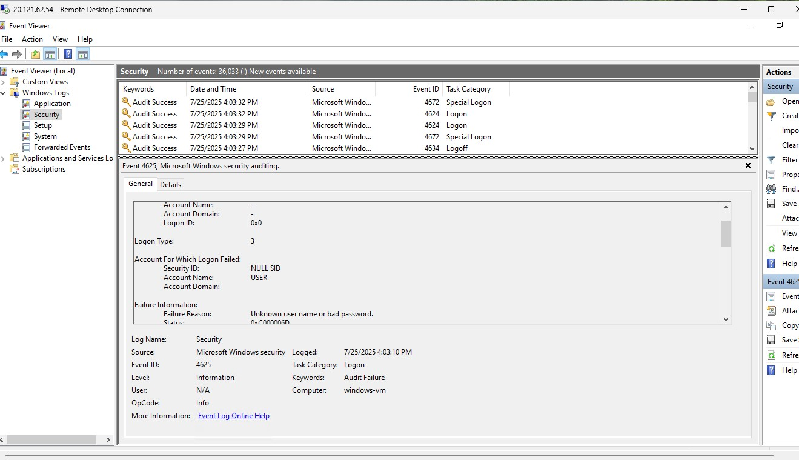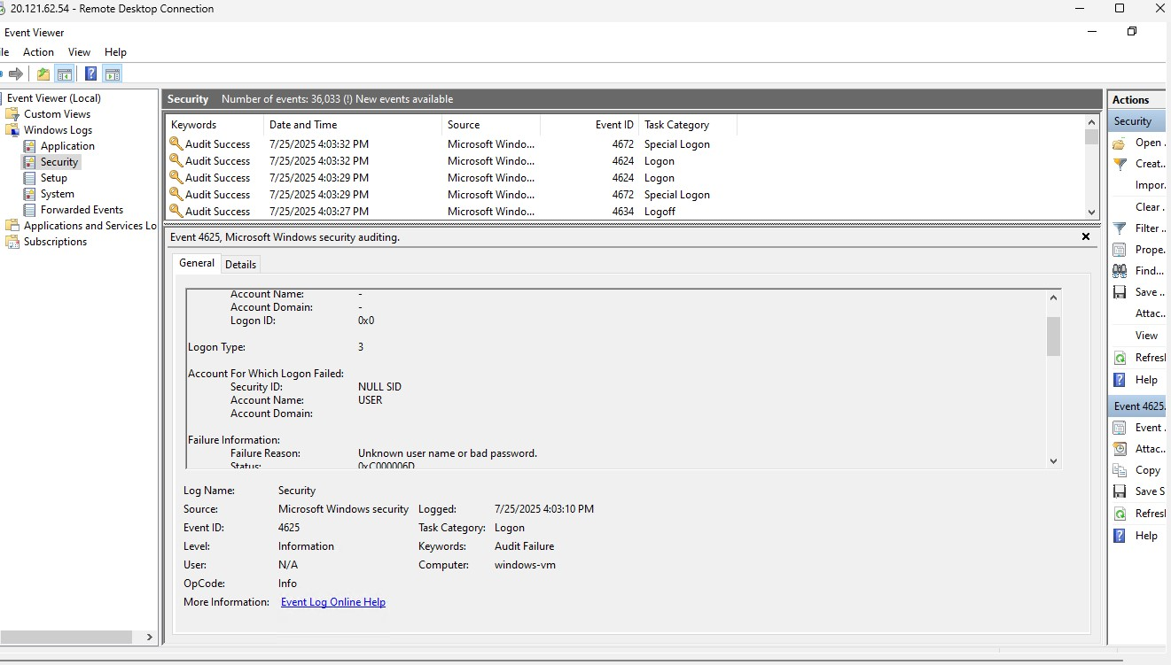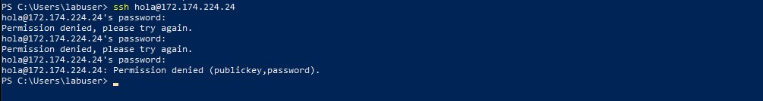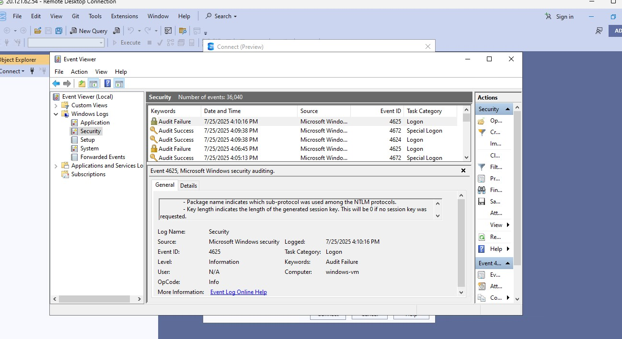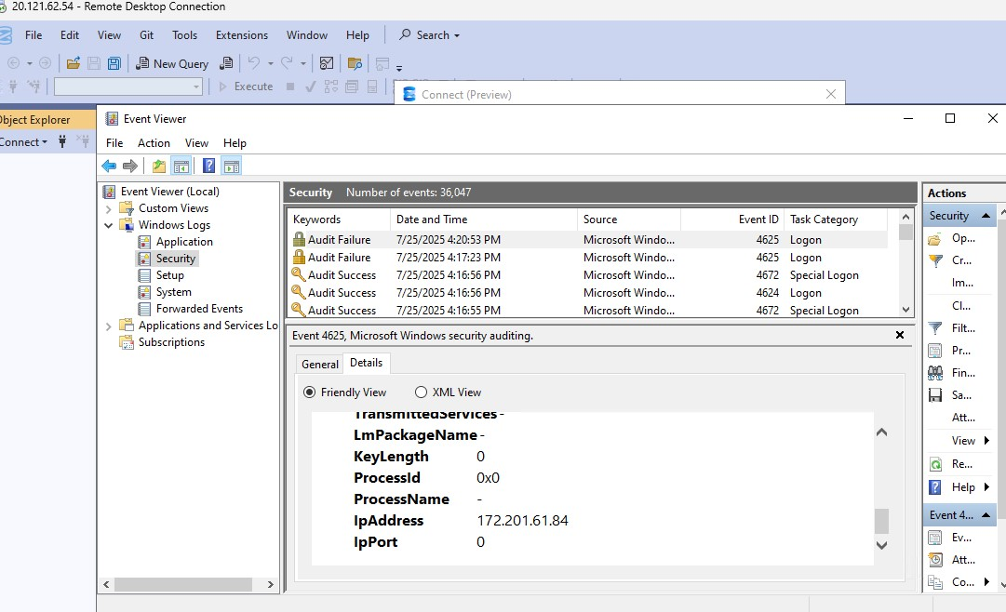

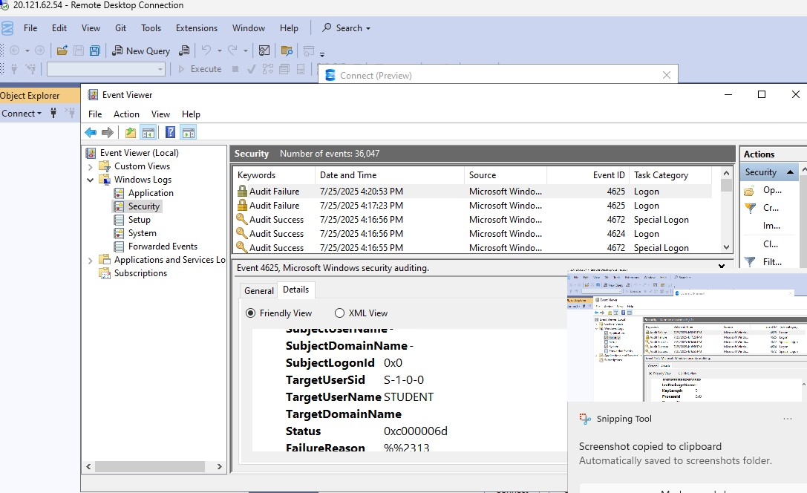

# 4. Linux VM Attack Monitoring

* Used SSH to access the Linux VM from Kali and the host.
* Commands used:
* cd /var/log
* cat auth.log | grep "Failed password"
* Successfully detected global SSH brute-force attempts within minutes of exposing the Linux VM.

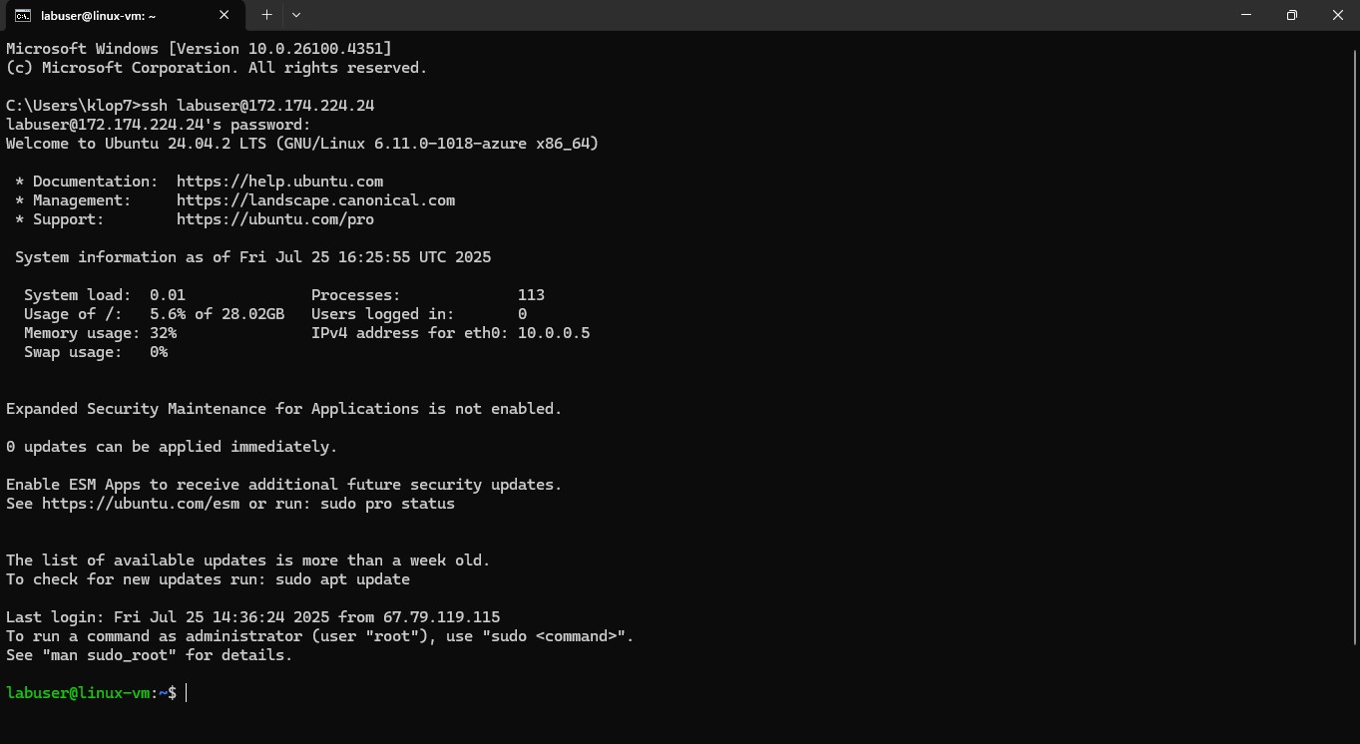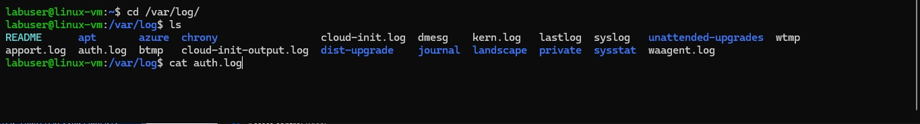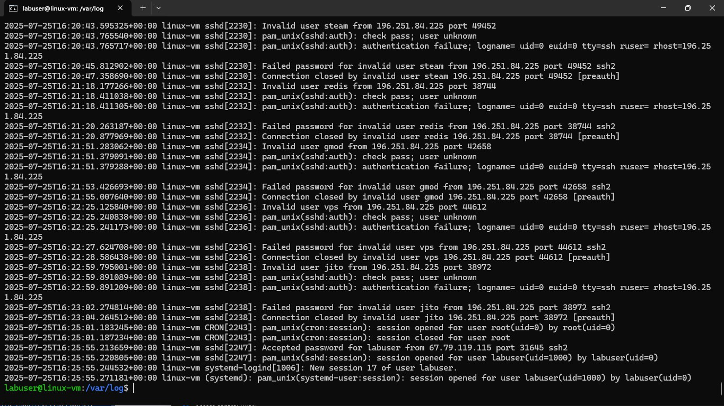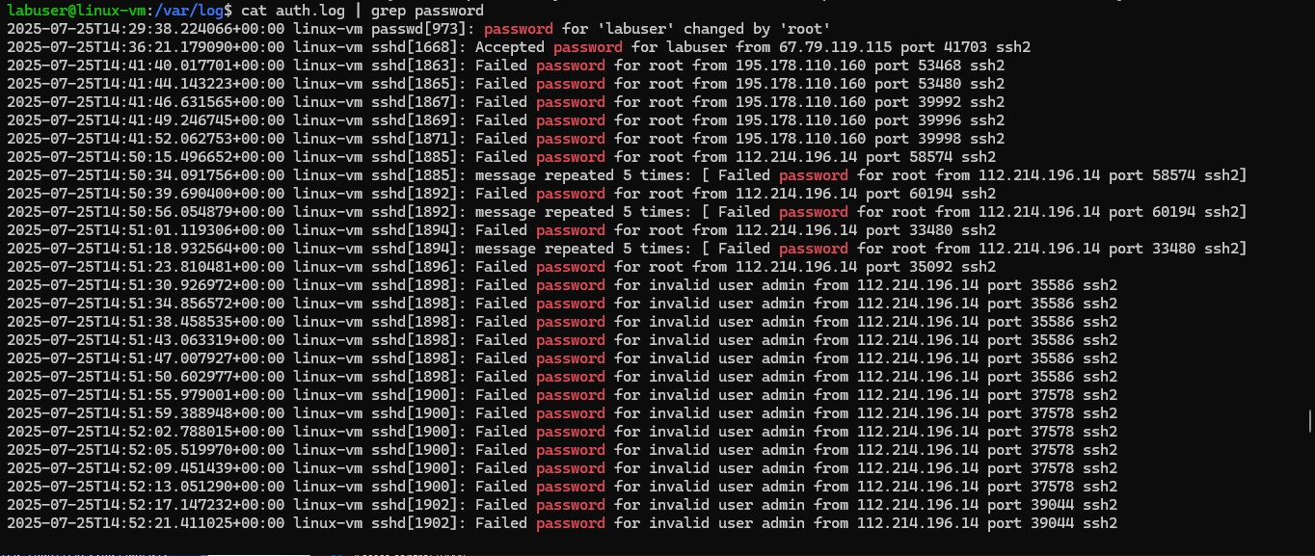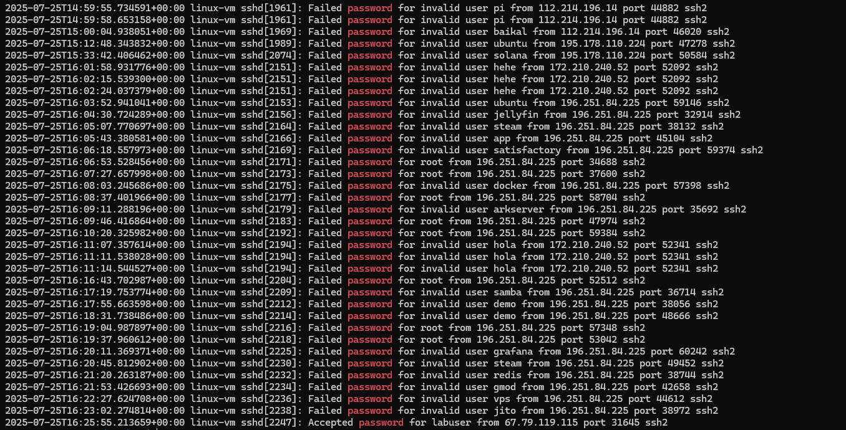

# 5. Attack Simulation from Kali (Attacker VM)

* Simulated RDP and SQL brute-force attacks on the Windows VM.
* Repeated incorrect login attempts via SSMS and RDP to generate events.
* SSH attempted into Linux VM using fake users to trigger logs like Permission denied.
* Verified the activity via: o **Event Viewer** on Windows. o **auth.log** on Linux.

# 6. Attempted Integration with Microsoft Sentinel

* Created a **Log Analytics Workspace** (law-rg-lab) under resource group rg-lab.
* Tried to connect Microsoft Sentinel and import **GeoIP watchlist** (goip-summarize.csv) from GitHub.
  + Successfully previewed 54,803 GeoIP records using: o _GetWatchlist('GeoIP') | count
* **Microsoft Defender for Cloud**:
  + Enabled plans for **Servers, SQL, Storage, Key Vault**. o Set **Data Collection** to *All Events*. o Configured **Continuous Export** (security score, alerts, compliance, etc.) to Log Analytics.

•

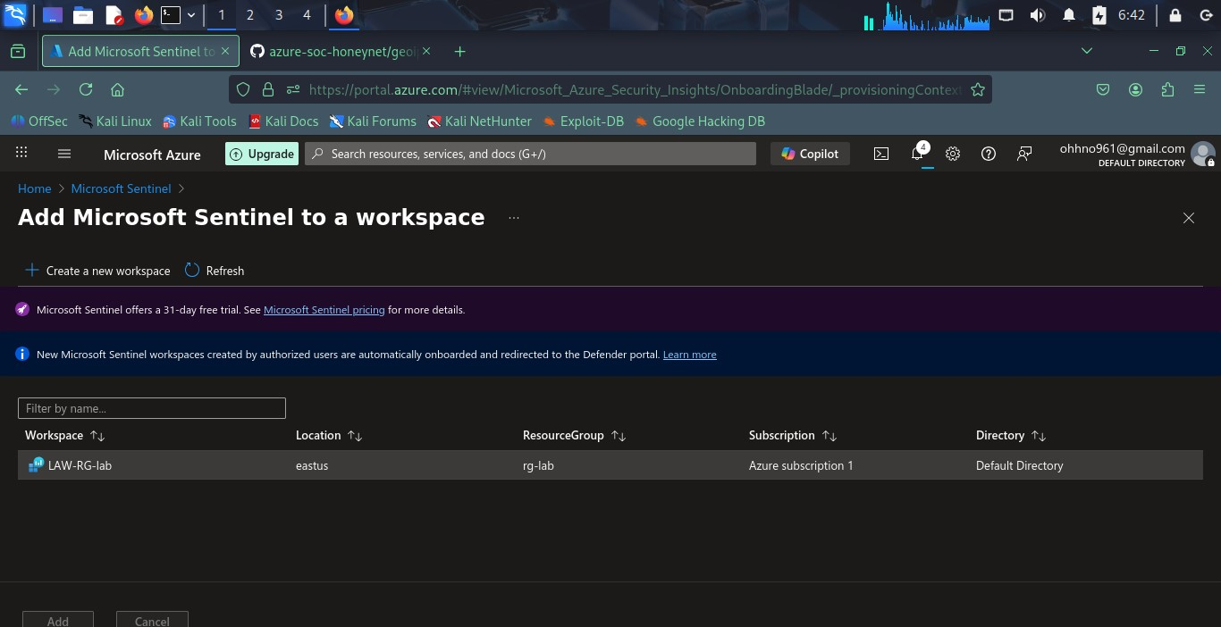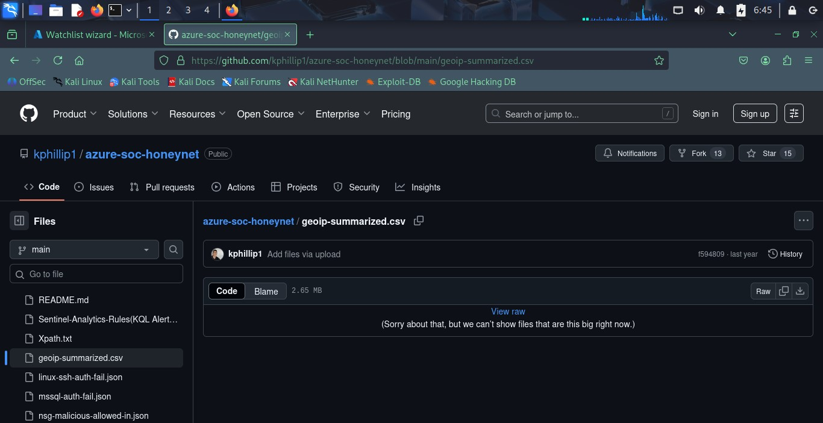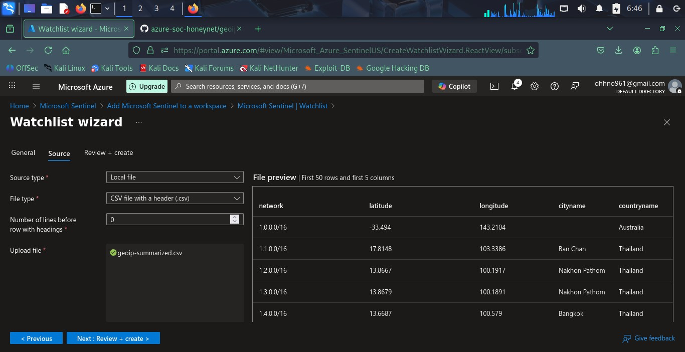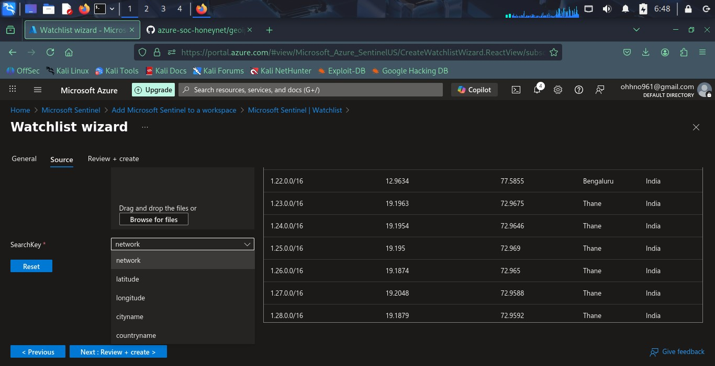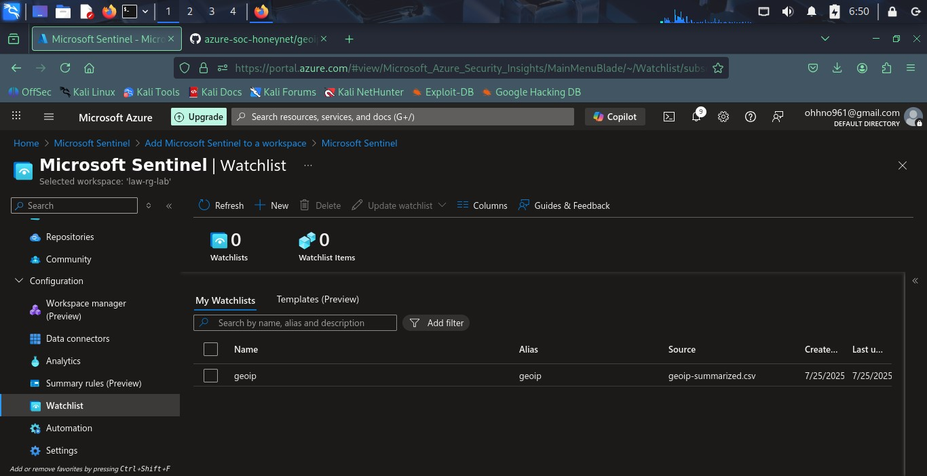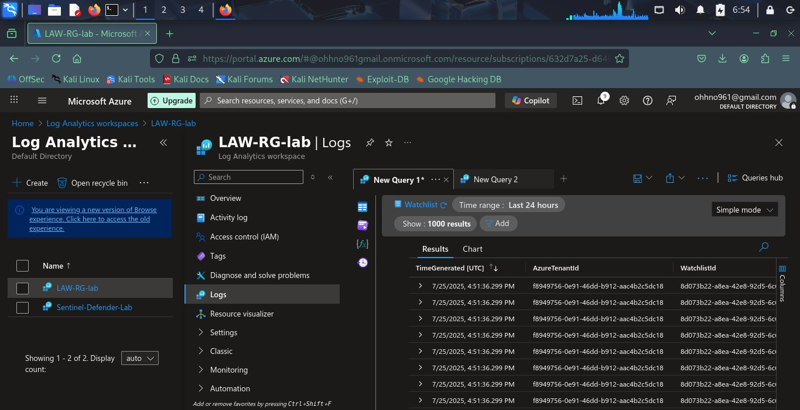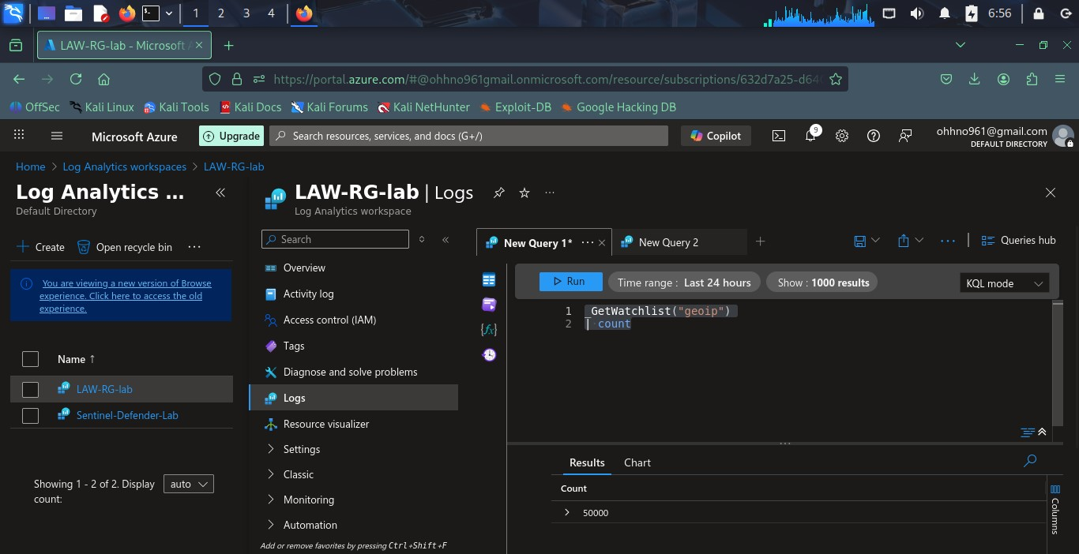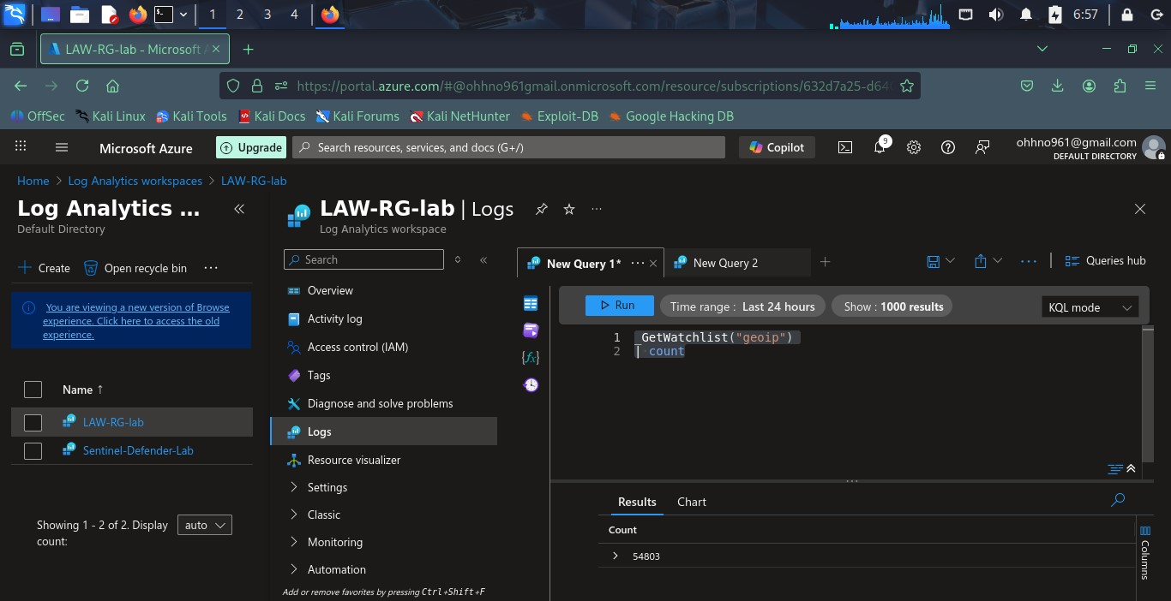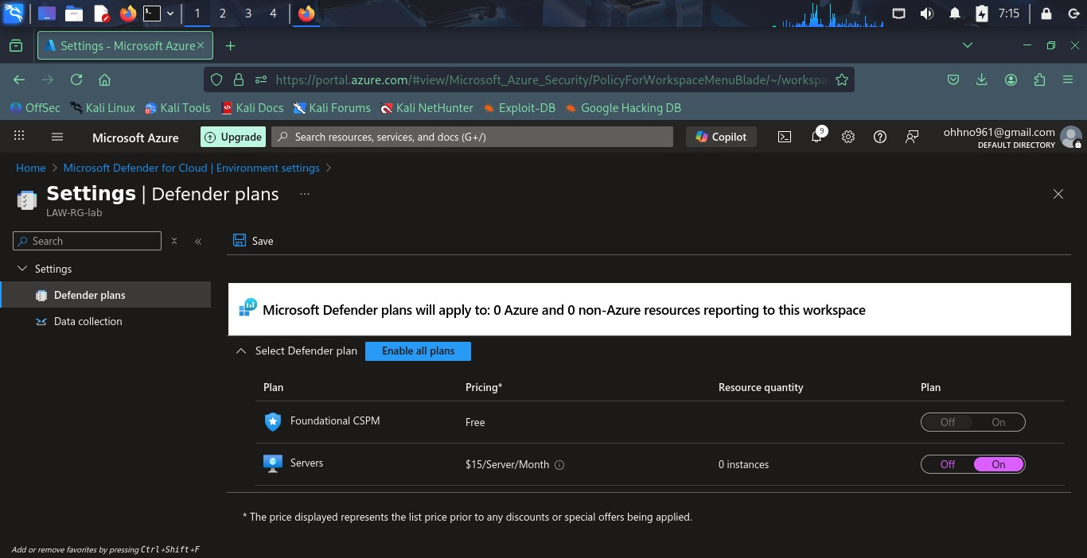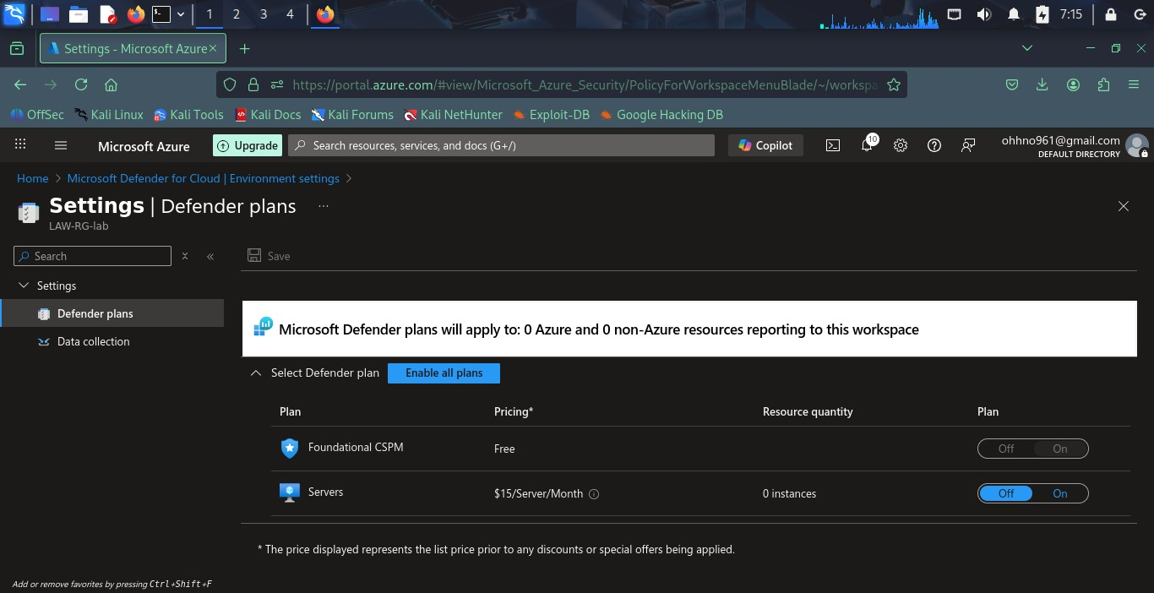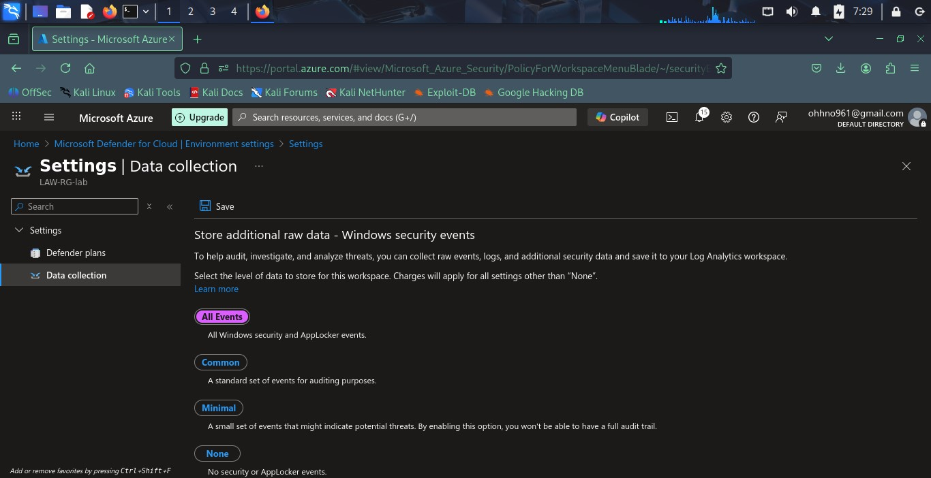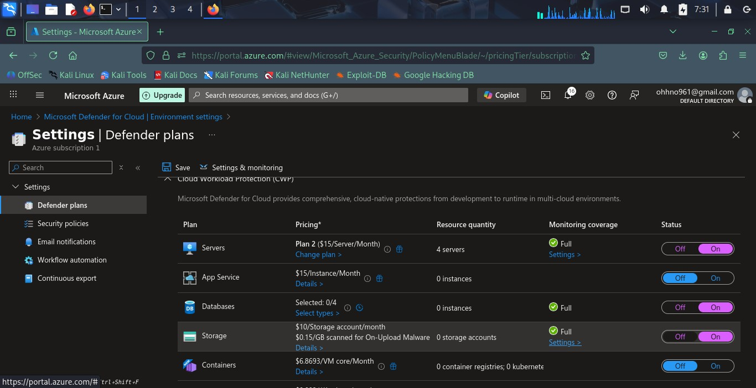

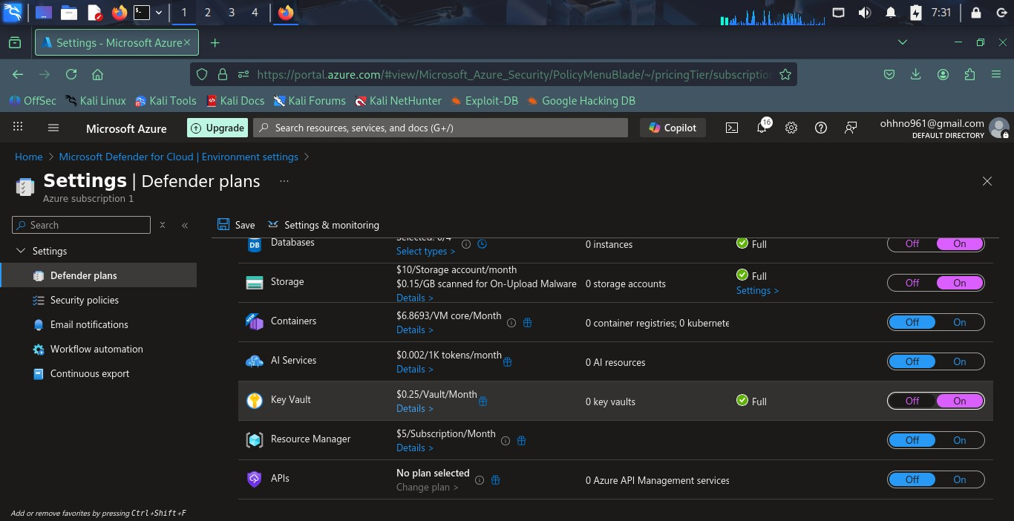

# • 7. Deployment Challenges

**Issue Attempted Fix Outcome**

NSG Flow Logs not Feature deprecated; failed to

Tried setting via Diagnostic Settings

available activate

Log Analytics Agent could Tried using Data Collection Rules Partially configured; not

not be deployed (DCR) for each VM fully functional

Did not proceed with

Event Hub setup Created namespace

integration

Azure CLI on VMs Tried SSH and manual configuration Unsuccessful

•



•

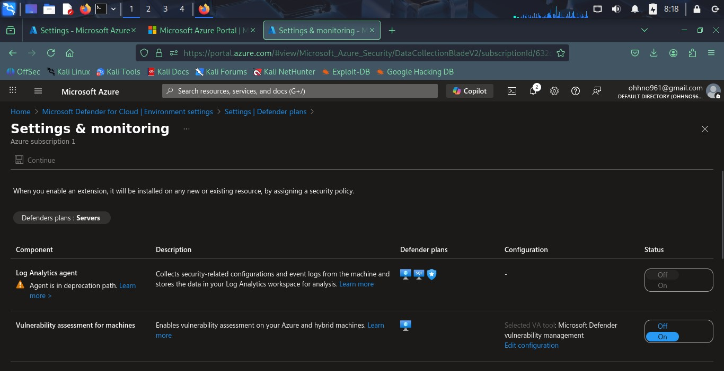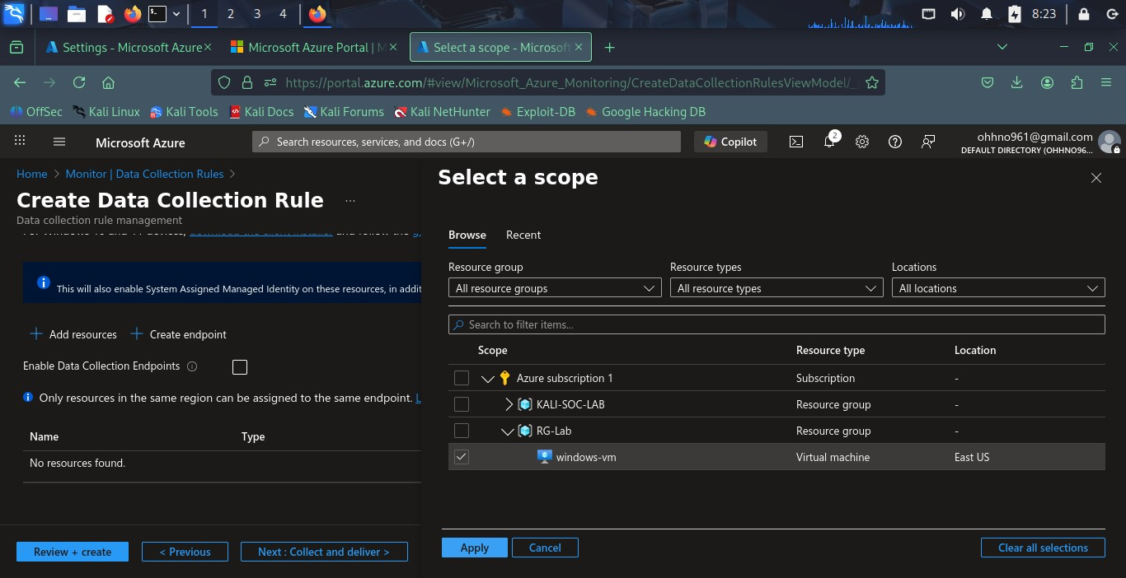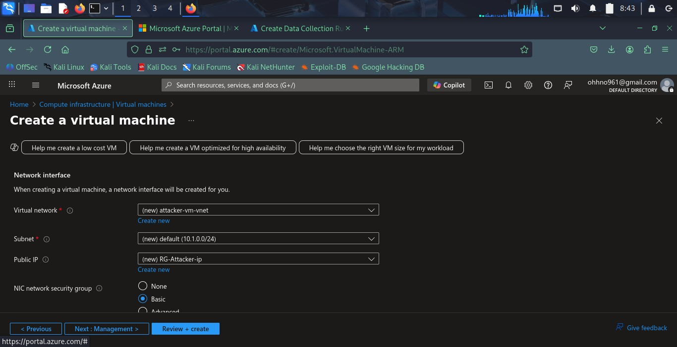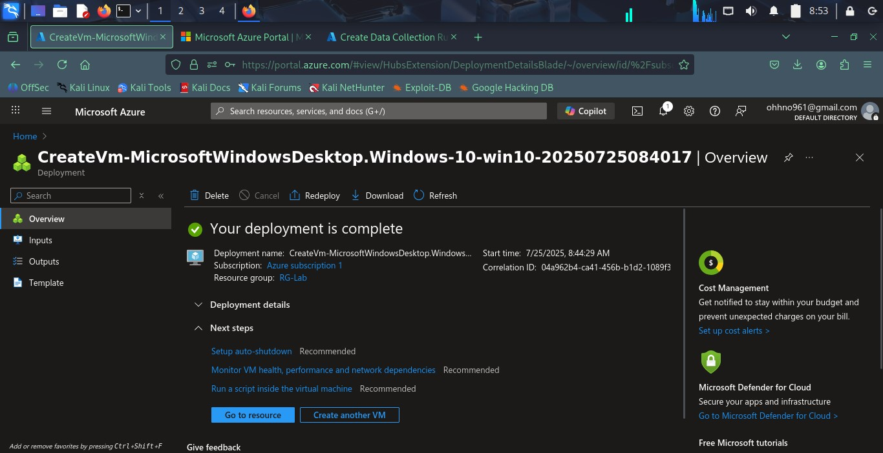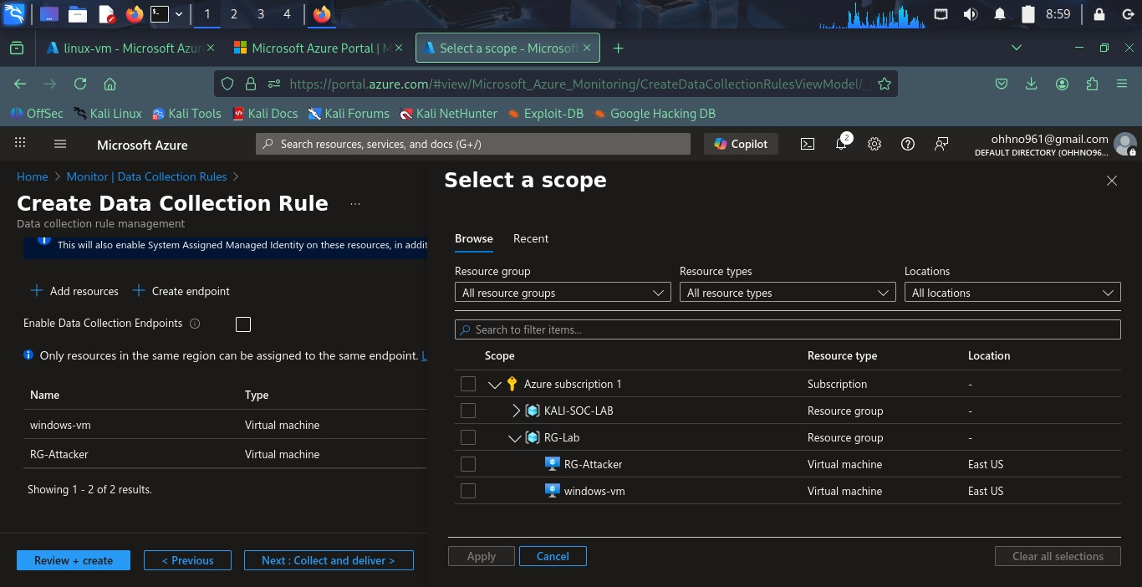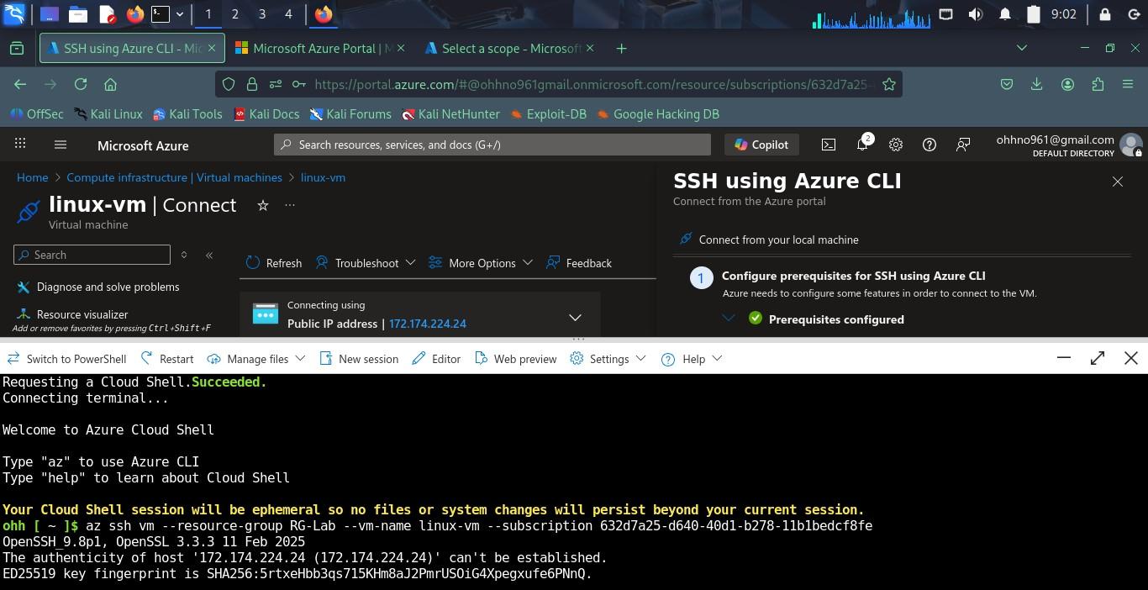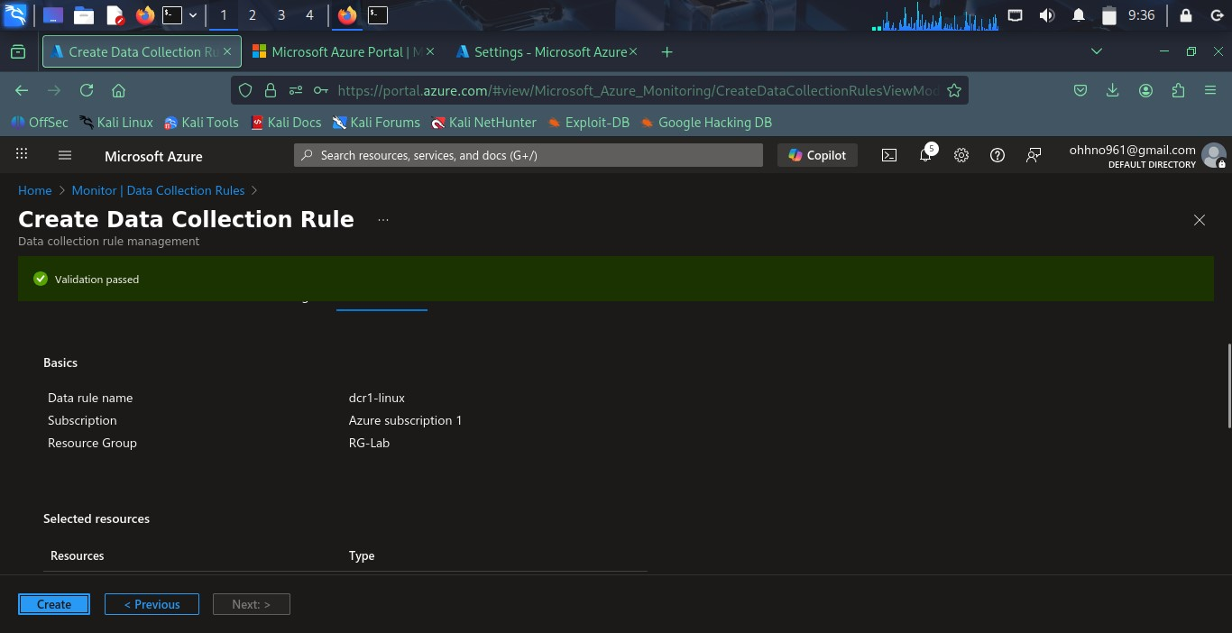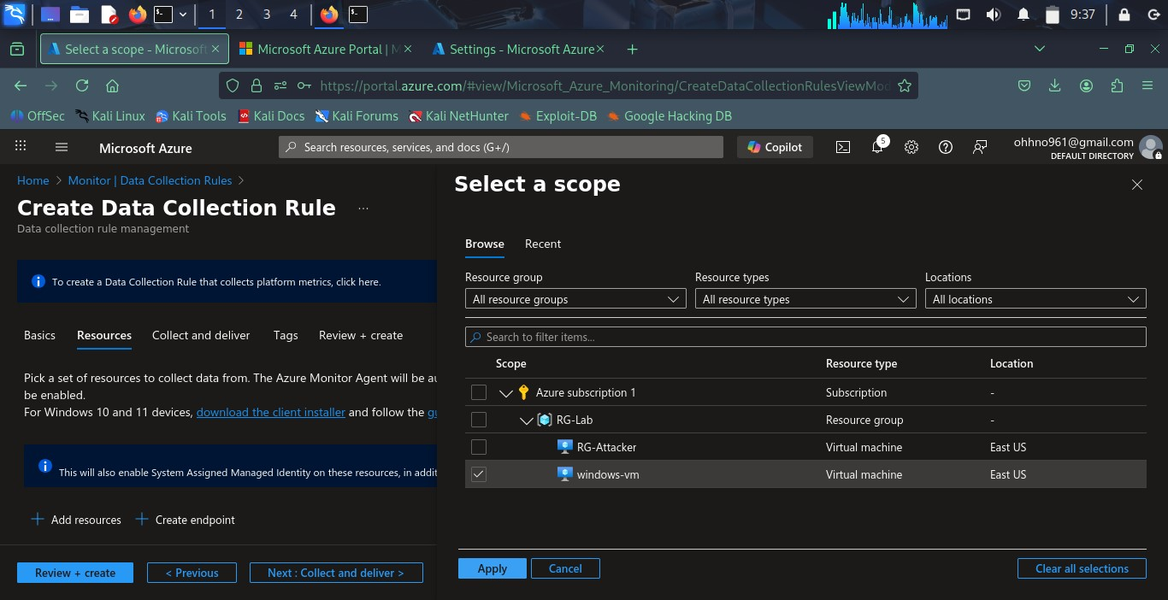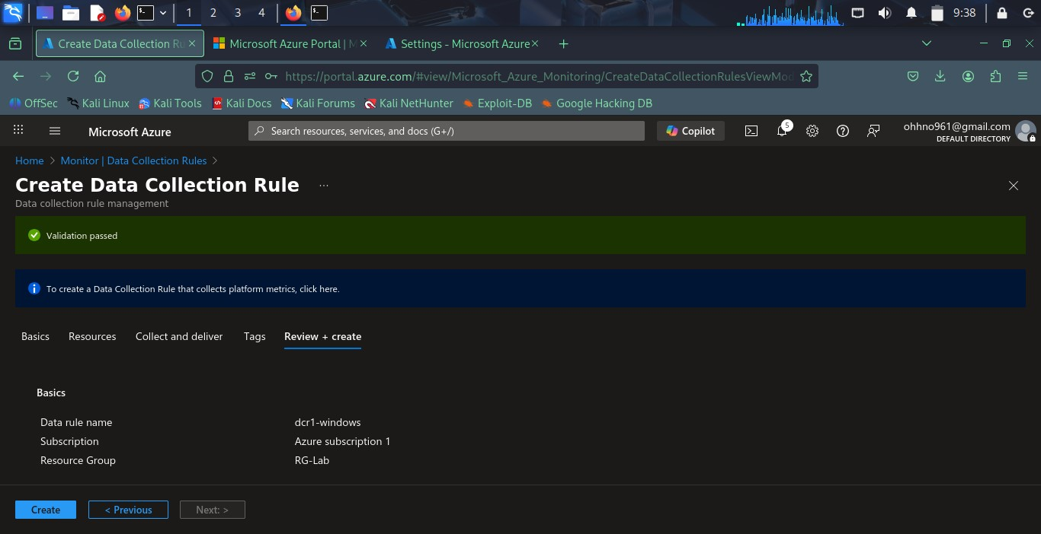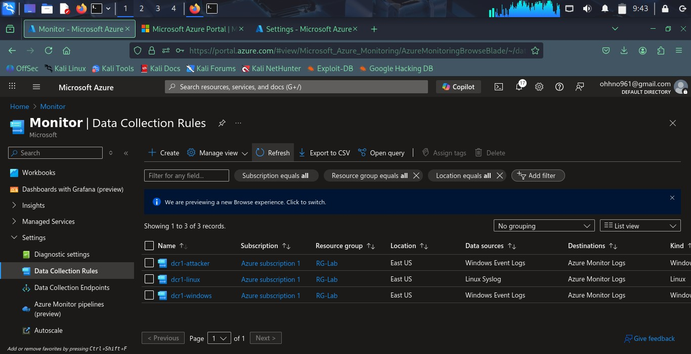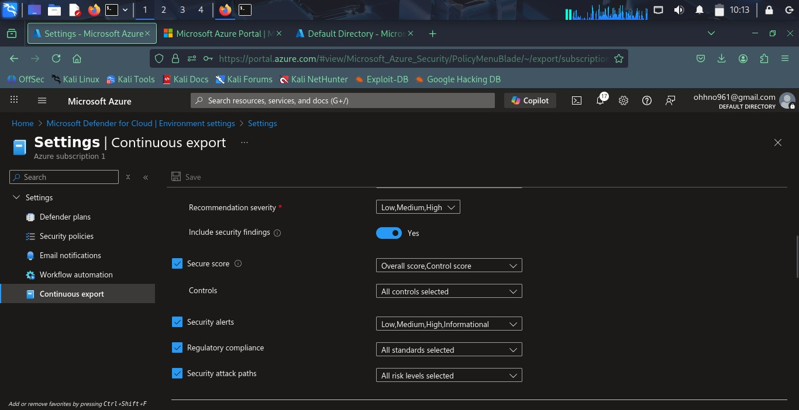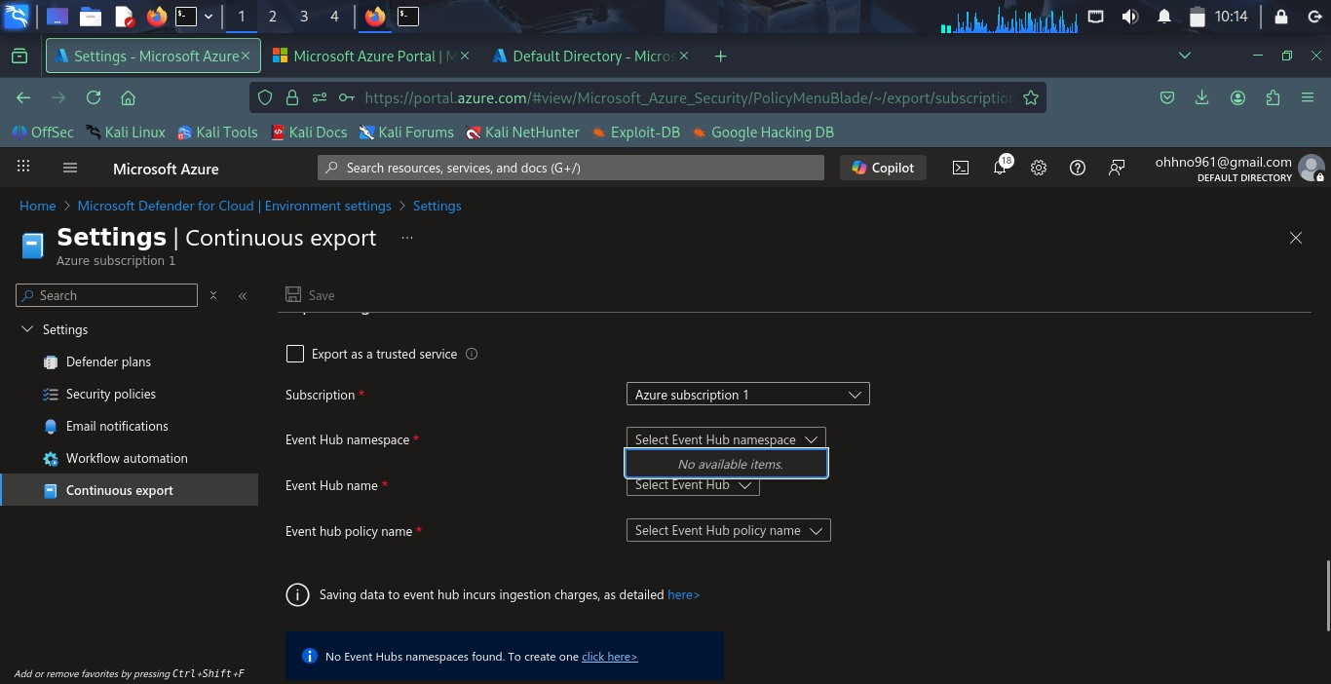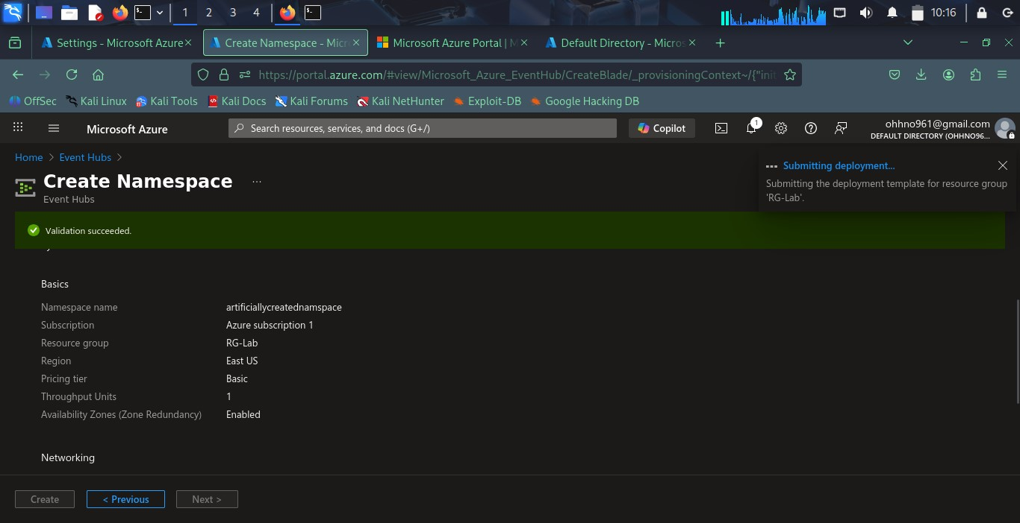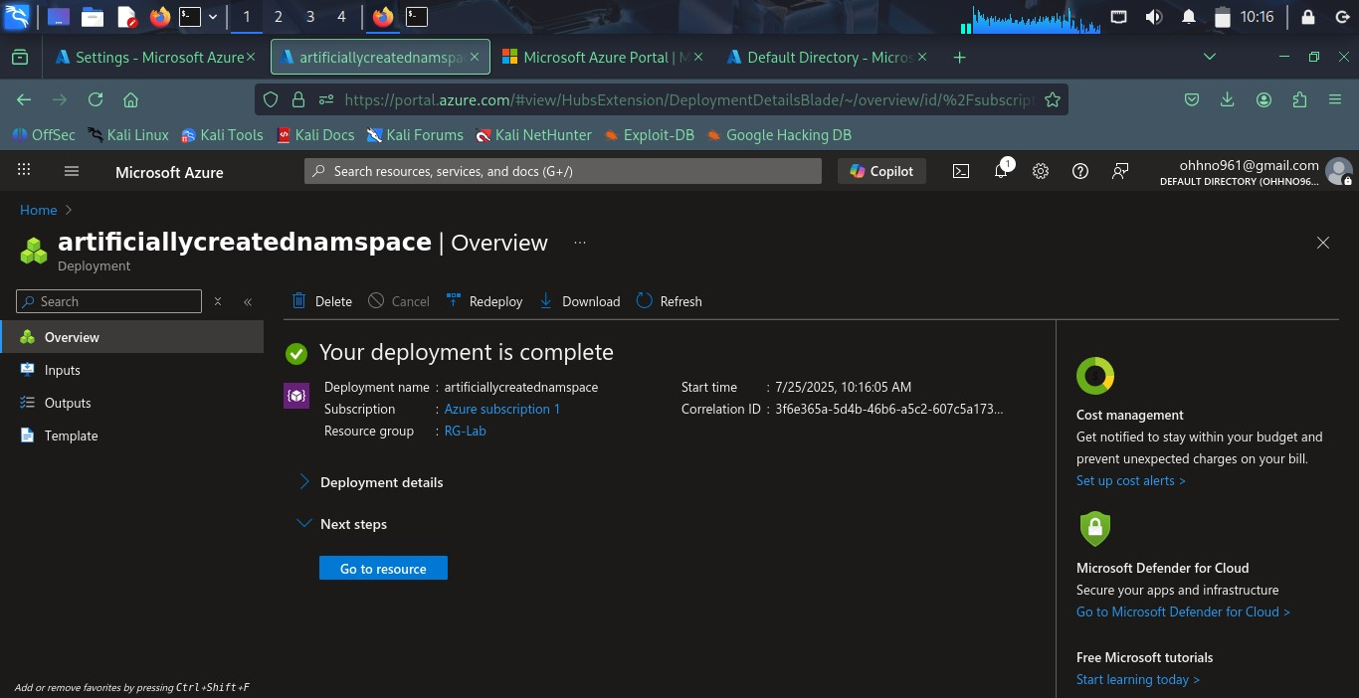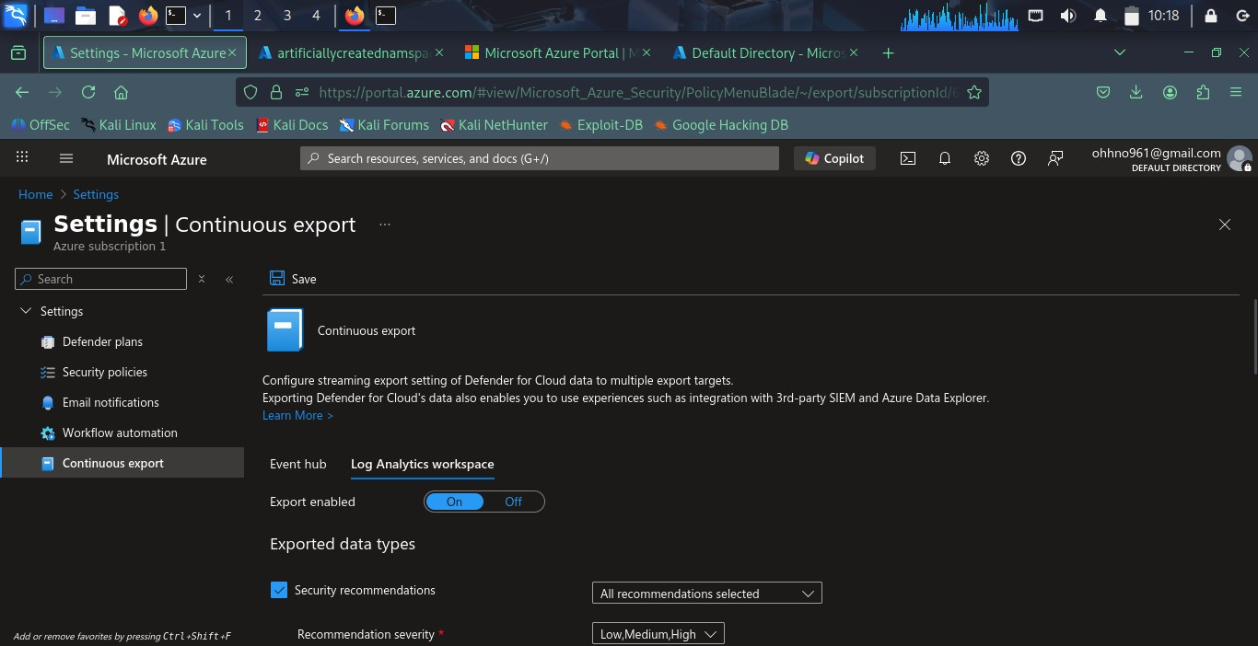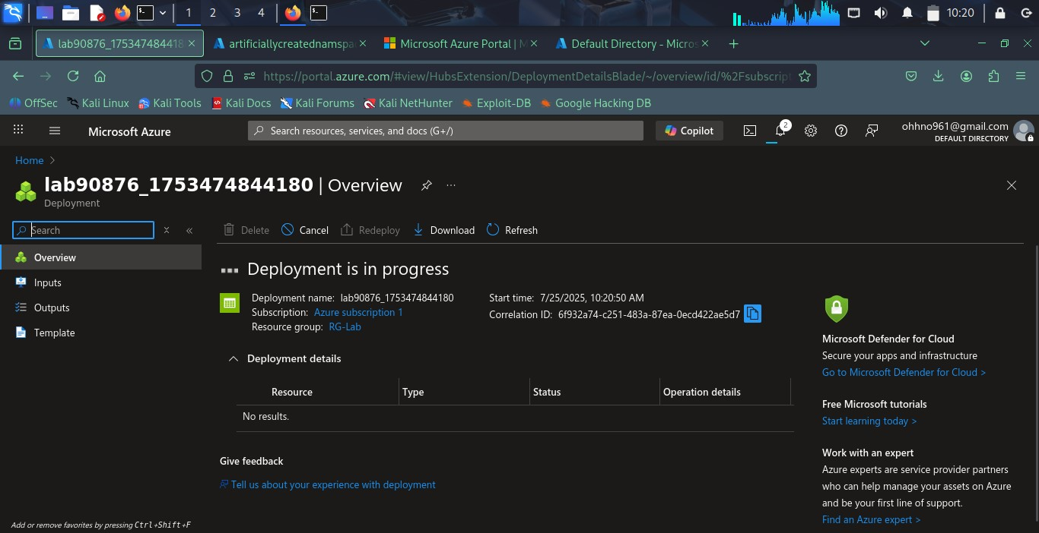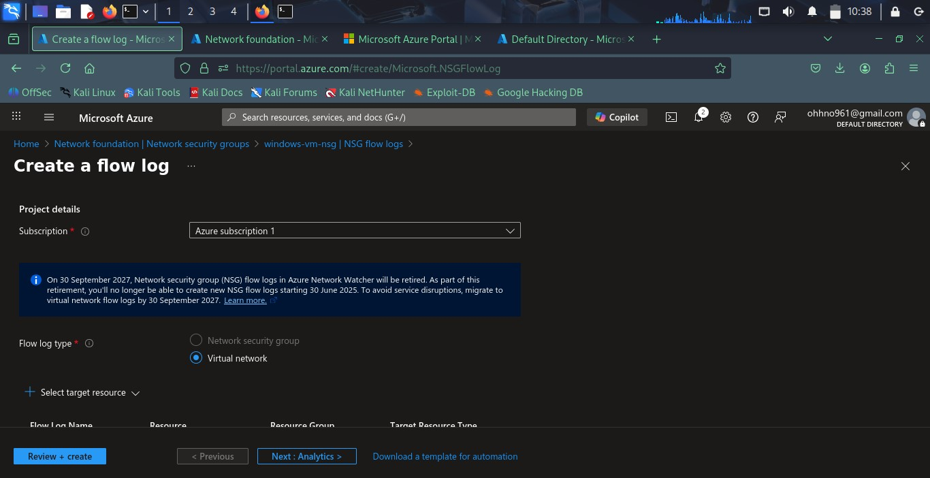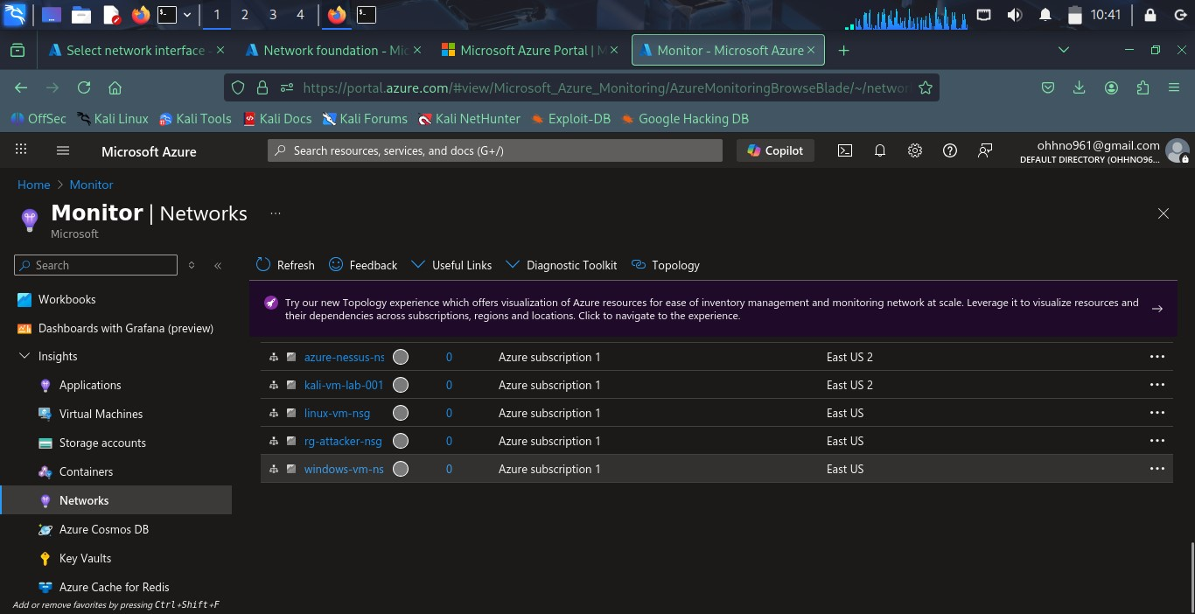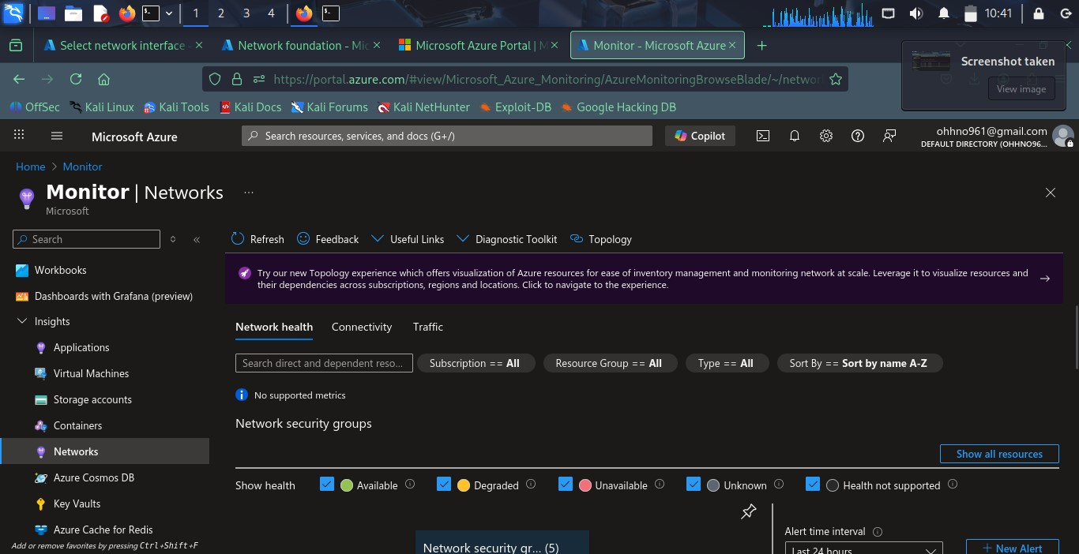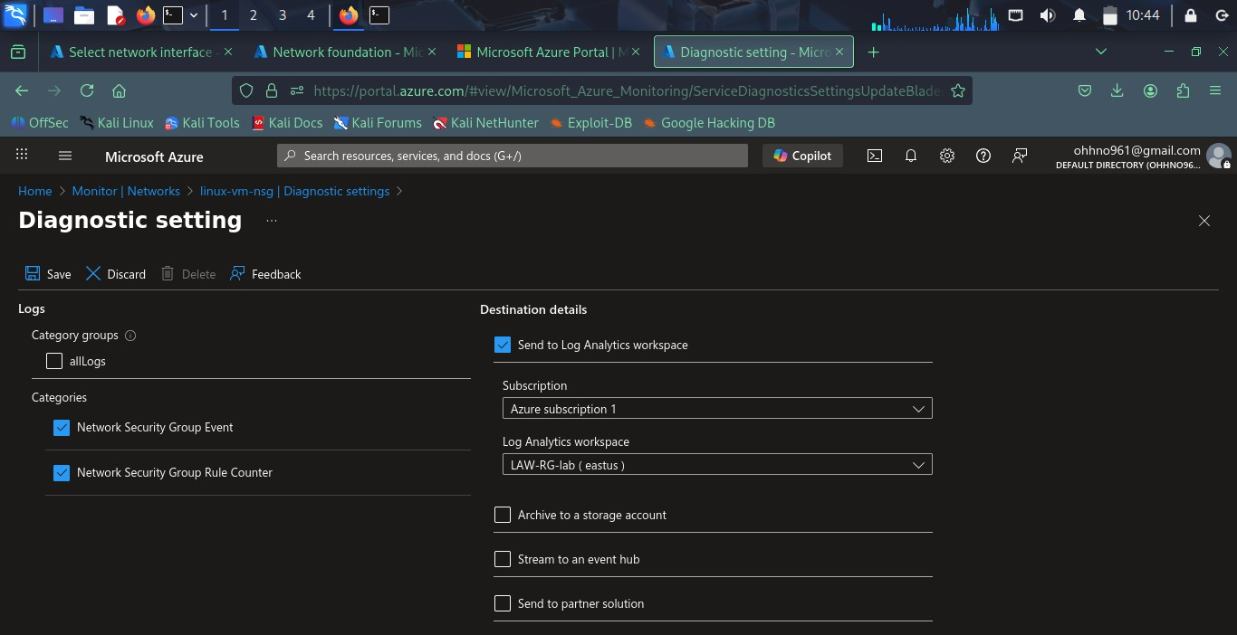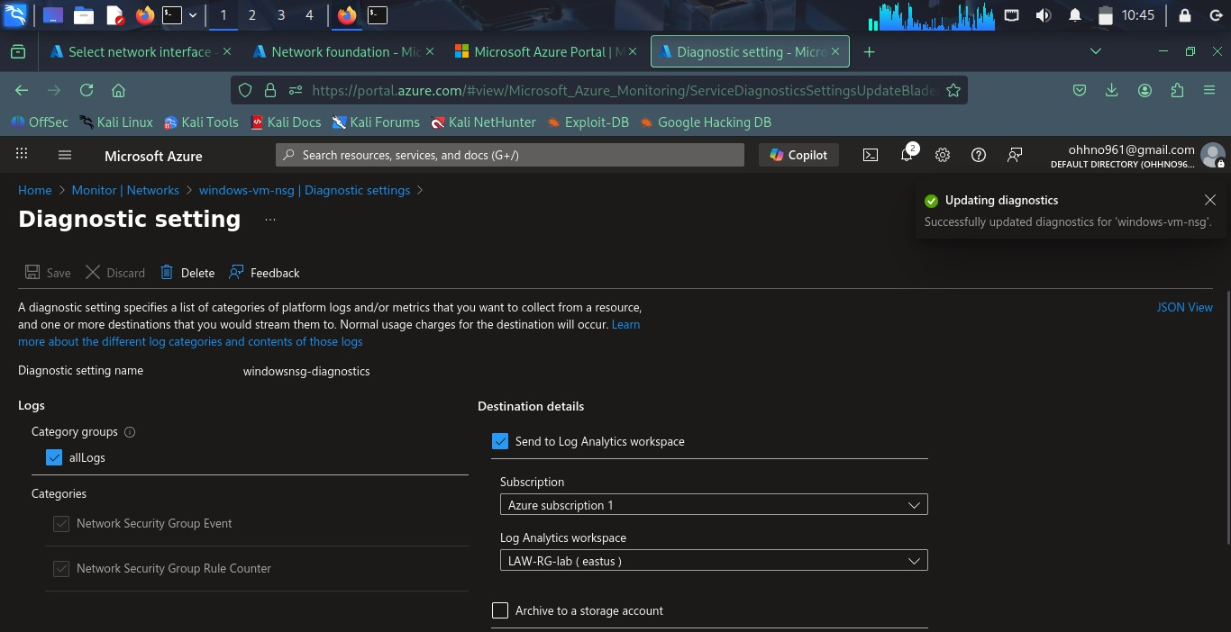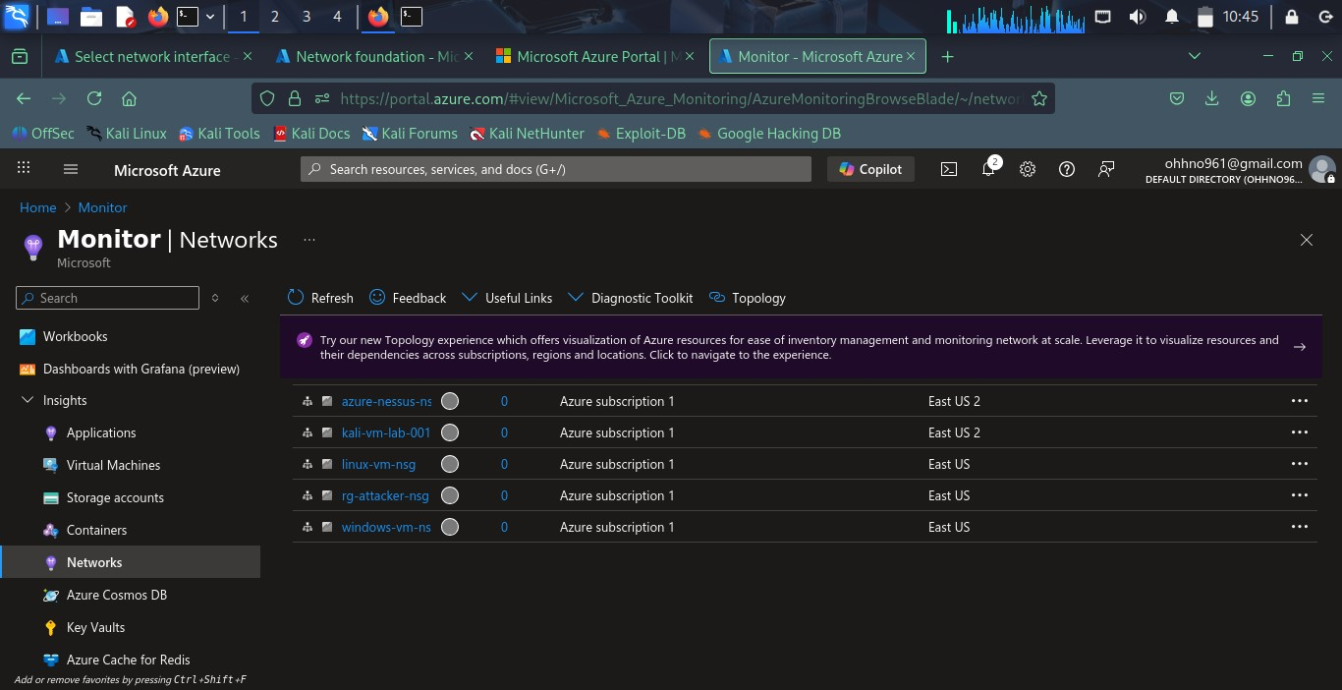

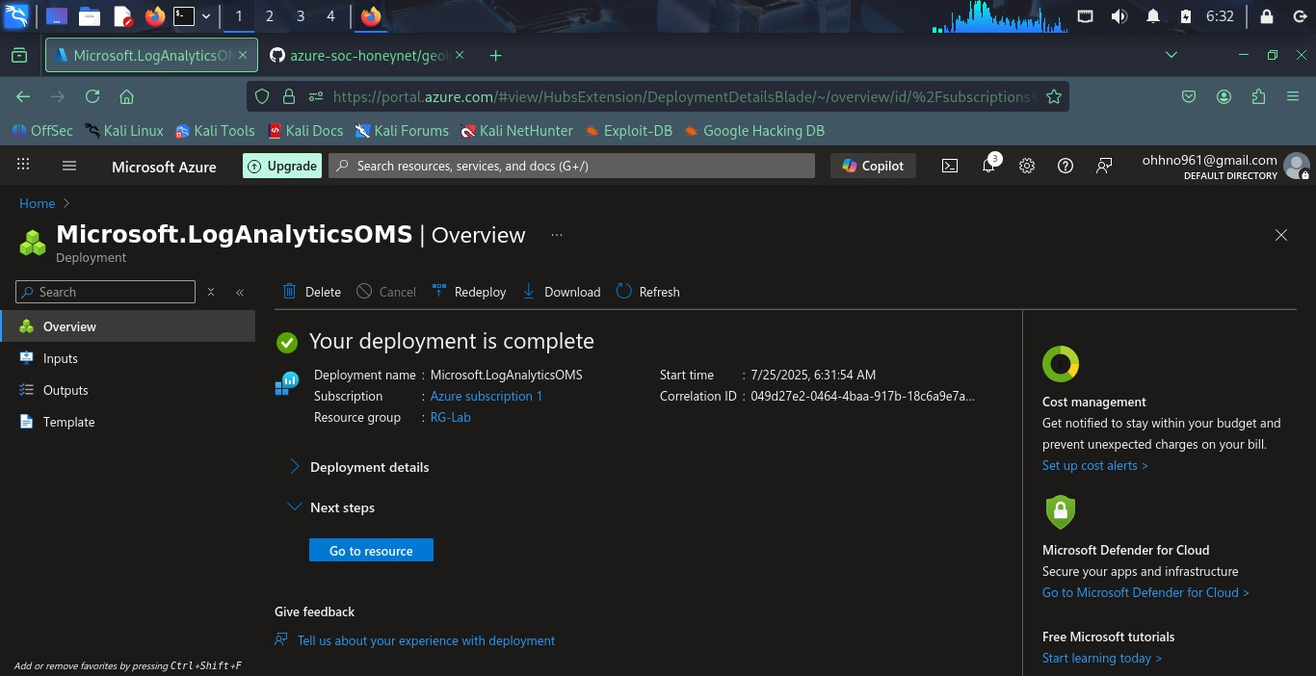

# 8. Lessons Learned

1. **Cloud Security is Fast-Paced**: NSG Flow Logs were deprecated mid-project, highlighting the need to monitor Azure documentation closely.
2. **Real-World Honeypots Work**: SSH attacks began within minutes of VM exposure.
3. **Data Integration Complexity**: Sentinel setup requires precise resource linkage and permissions.
4. **Hands-on Beats Theory**: Despite technical roadblocks, this project built real muscle in Azure networking, logging, and detection workflows.

**Final Reflection:**

Although I couldn’t fully complete the Sentinel integration in this project, I gained *far more than expected* through deep troubleshooting, real-world experimentation, and grappling with Azure’s fast-evolving ecosystem.

* I discovered that **several features I relied on had been deprecated or renamed** (e.g., NSG Flow Logs), and even with an active Azure subscription, some **critical services were unavailable or restricted**, requiring creative workarounds.
* These blockers pushed me to **explore alternative paths**, including testing Data Collection Rules (DCR), GeoIP watchlists, and brute-force simulations across OS types.
* More importantly, I realized that **real-world cybersecurity doesn’t follow a script**— things break, tools change, and documentation goes stale. That’s when learning becomes *real*.

This project taught me how to:

* Architect cloud-based honeypot environments
* Simulate and detect attacks from both internal and external threat vectors
* Interpret logging systems across Windows and Linux
* Navigate Azure’s shifting security landscape with persistence and critical thinking

I plan to **re-attempt this project soon**, building on these lessons, and will aim for full Microsoft Sentinel integration using custom DCR, Azure Monitor Agent, and third-party analytics pipelines.

In cybersecurity, progress isn’t just measured by what *worked*—but by how much you *understood when things didn’t*. This was one of those turning-point labs.